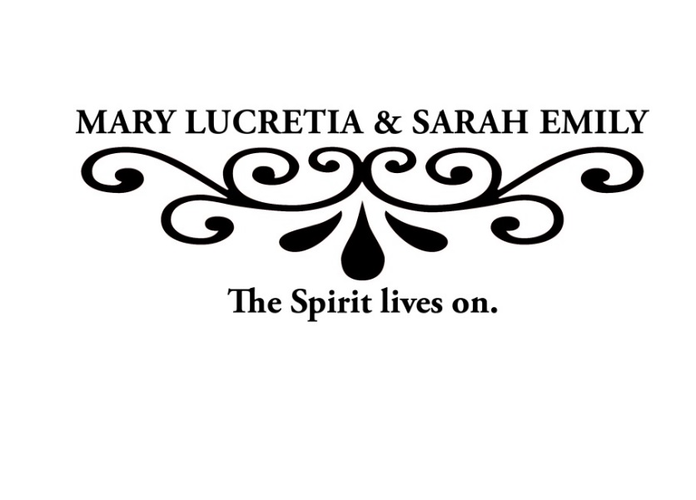

The luncheon is complimentary, but **reservations are required.** Reservations for full tables of 10 are preferred. Please have one person submit the reservation and serve as your table’s primary contact. Meal tickets will be sent to the contact person the week of the luncheon. ***Departments are limited to one table per department.***

To reserve a table, please fill out the information below and return it to [angelarickels@creighton.edu](mailto:angelarickels@creighton.edu) by **Monday, January 23, by 4:30 p.m.**

The Committee on the Status of Women is pleased to announce the

recipients of the 2017 Mary Lucretia & Sarah Emily Creighton Awards:

**Deborah L. Wells, Ph.D. Mary E. Chase, Ed.D. Rachel Marie Lee**

Senior Associate Dean Vice Provost for Enrollment Creighton School of Law

Heider College of Business and University Planning Third Year Student

37th Annual Mary Lucretia & Sarah Emily Creighton

Awards Recognition Luncheon

Thursday, February 9, 2017

11:30 A.M.

Mike and Josie Harper Center, Ahmanson Ballroom

Primary Contact:

Department/Group Name:

Reservation information

____ Table of 10 OR ____ # of attendees (no more than 10)

Please list your table’s meal preferences.

____ Hanger Steak (GF) ____ Vegetarian Potato Pave w/ Mushrooms & Quinoa (GF)

____ Special dietary needs:_________________________

R

S

V

P