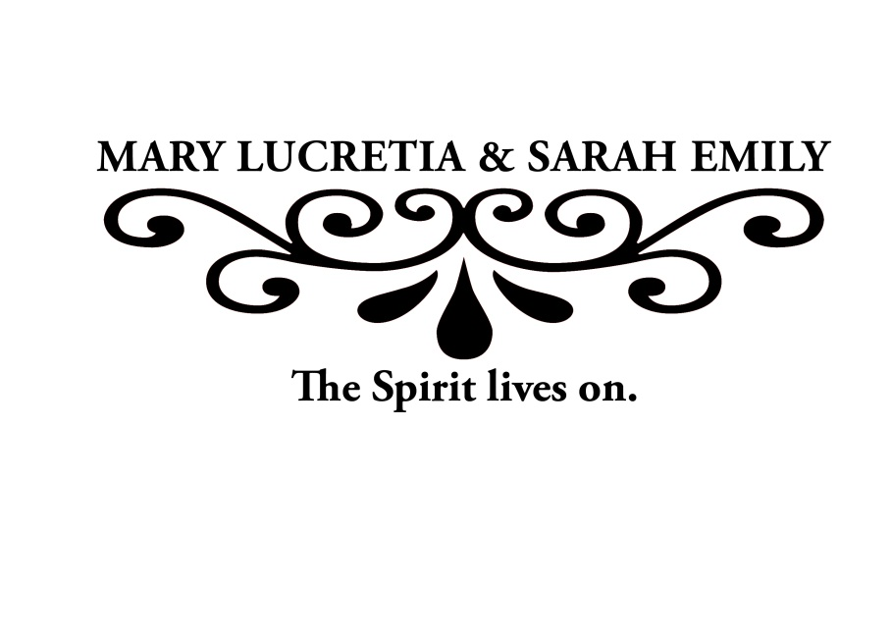

Primary Contact:

Department/Group Name:

Reservation information

____ Table of 10 ____ ½ Table of 5 ____ Single Reservation

Please list your table’s meal preferences.

____ London broil ____ Vegetarian Portobello Mushroom Napoleon

____ Special dietary needs:_________________________ 

The Committee on the Status of Women is pleased to announce the

recipients of the 2015 Mary Lucretia & Sarah Emily Creighton Awards:

**Megan Bullard Diane Cullen, Ph.D. Jim Flanery**

Arts & Sciences Junior Professor of Biomedical Sciences Head Coach Women’s Basketball

Student Leader School of Medicine Athletics

**35th Annual Mary Lucretia & Sarah Emily**

**Creighton Awards Recognition Luncheon**

**Thursday, February 5, 2015**

**11:30 A.M.**

**Mike and Josie Harper Center, Ahmanson Ballroom**

The luncheon is complimentary, but **reservations are required.** To reserve a table, please fill out the information below and return it to [tamithibodeau@creighton.edu](mailto:tamithibodeau@creighton.edu) by **Monday, January 26, by 4:30 p.m.**

Reservations for full tables of 10 are preferred. Please have one person submit the reservation and serve as your table’s primary contact. Meal tickets will be sent to the contact person the week of the luncheon.

This is on a first come/first serve basis.

R

S

V

P