Instructions for Completing the New Program Template
Click on http://www.creighton.edu/finance/budget/policiesprocedures/index.php
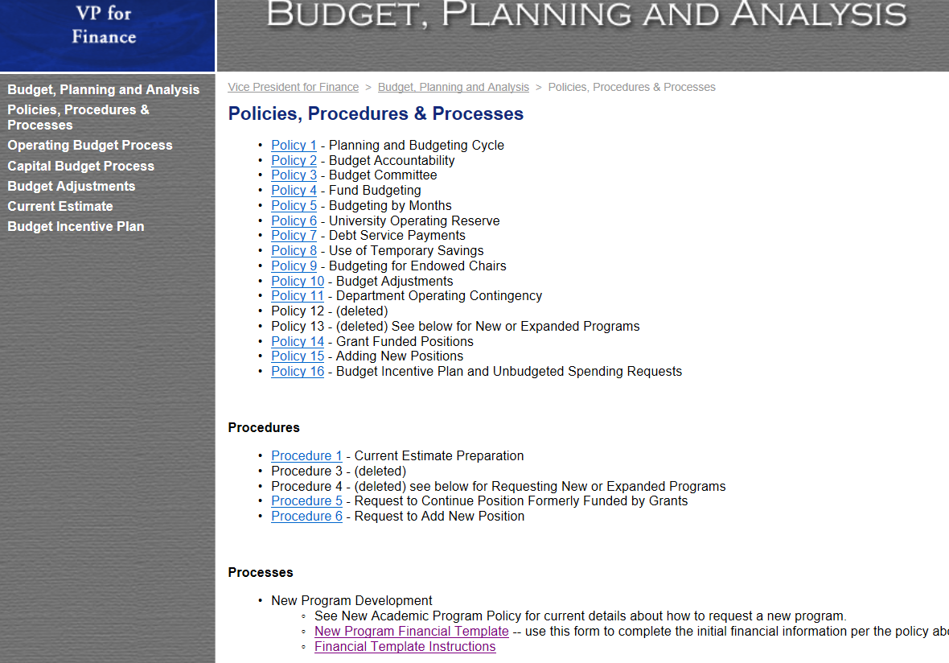
Go to the link “New Program Financial Template”
Open the file.
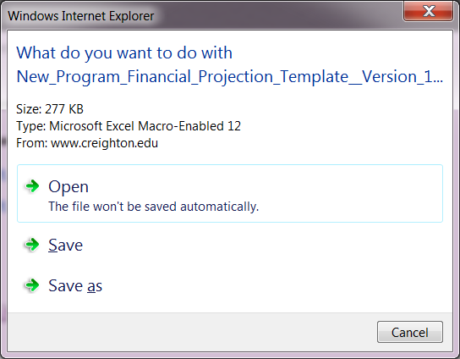

This form is an overview of the new program contact information, key assumptions and will calcuate tuition revenue based on the number of students, credit hours, etc.
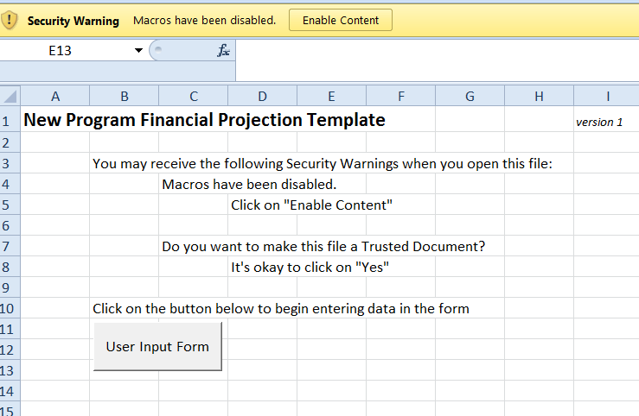
Before you can work in the template, you need to click on the Enable Content button to enable macros.
A security warning will pop up asking you if you want to make it a trusted document. If you choose yes, you will not have to enable the macros everytime you open the file. If you choose no, you will have to enable the macros everytime you open the file.
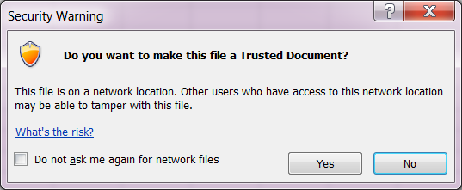
Click on the User Input Form button.
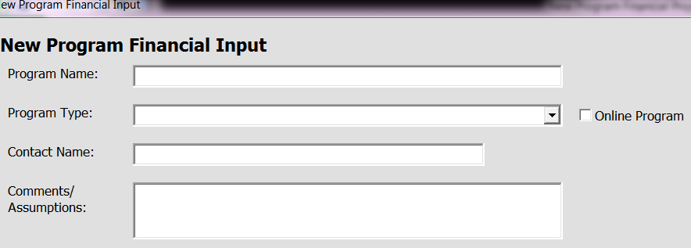
Begin by entering the Progam Name
For Program Type – use the drop down arrow to pick the type of program. This will enable you to begin working on entering the data in the user form for the specific revenue type you selected. There can be a combination of revenue types that we will receive from a new program. In that case, work each one individually.
- Traditional Undergraduate Revenue
- Non-Traditional Undergraduate Revenue
- Graduate Program Revenue
- Certificate Program - Flat Rate
- Certificate Program - Credit Hour Based
- Other Revenue
If the progam will be on-line – click the On Line check box.
Contact Name is the person would is proposing the new program.
Enter the general assumptions that you are making, such as whether or not it’s a cohort or open enrollment program for example, in the Comments/Assumptions section. This is for any additional information that is helpful in explaining the financial assumptions. Specifics such as enrollment, tuition rates and discount will be entered in the revenue sections.
Once the Program Type is selected, input the revenue assumptions, see below, for each of the five years.

- Traditional Undergraduate Revenue
  - Expected full time enrollment counts by year for the first 5 years of the program, by term if known, by class
    - Fall:
      - Freshmen
      - Sophomore
      - Junior
      - Senior
    - Spring:
      - Freshmen
      - Sophomore
      - Junior
      - Senior
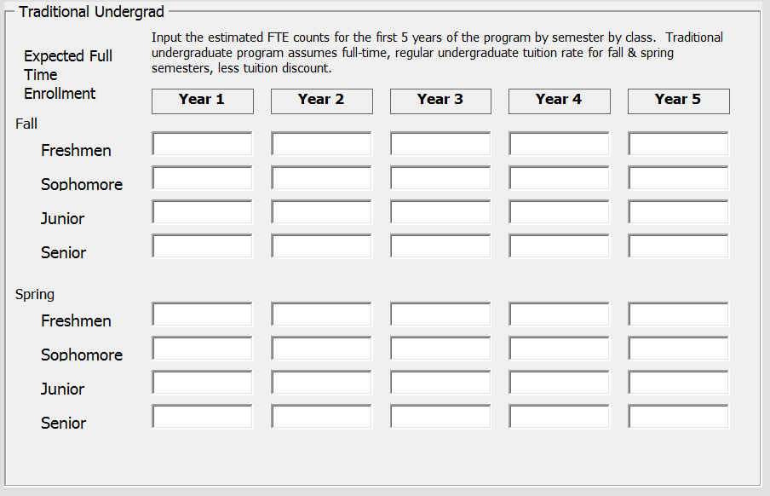

- Non-Traditional Undergraduate Revenue
  - Expected enrollment counts by year, by class, for the first 5 years of the program, by term if known
    - Freshmen
    - Sophomore
    - Junior
    - Senior
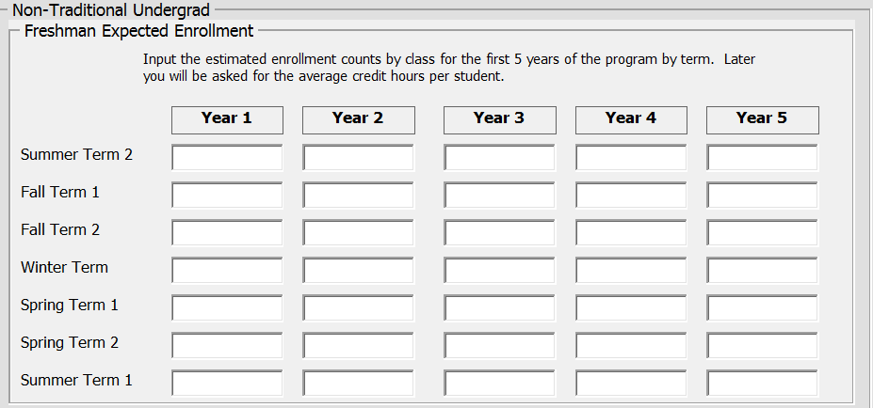
  - Average Credit Hours Per Student
  - Tuition per credit hour (current base is $400 based on the BILS program, next fiscal year’s base is estimated to be $412).
  - Tuition discount rate
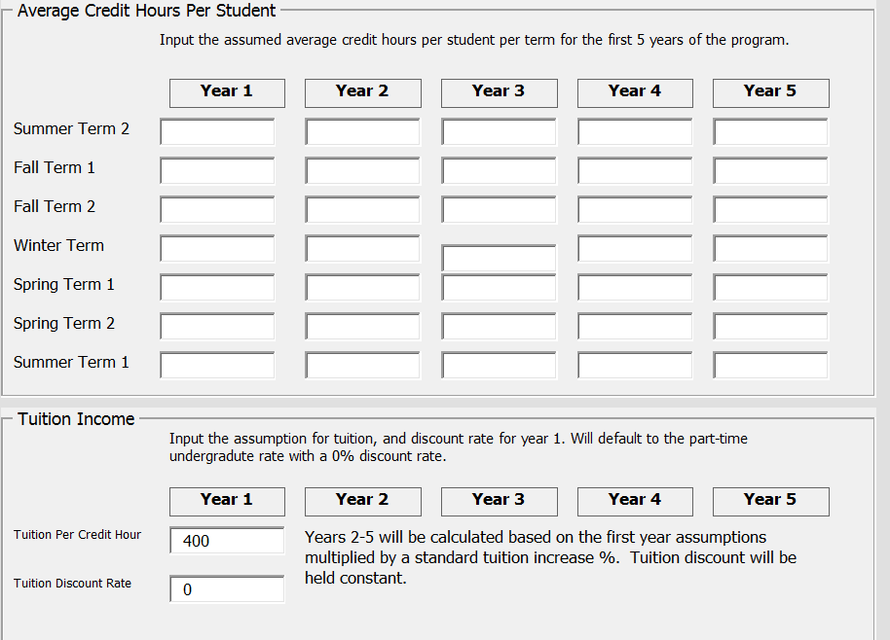

- Graduate Program Revenue
  - Expected enrollment counts by year for the first 5 years of the program, by term if known
    - 1st year students
    - 2nd year students
  - Average Credit Hours Per Student
    - 1st year students
    - 2nd year students
  - Tuition per credit hour (current base is $756, next fiscal year’s base for graduate is estimated to be $780).
  - Tuition discount rate
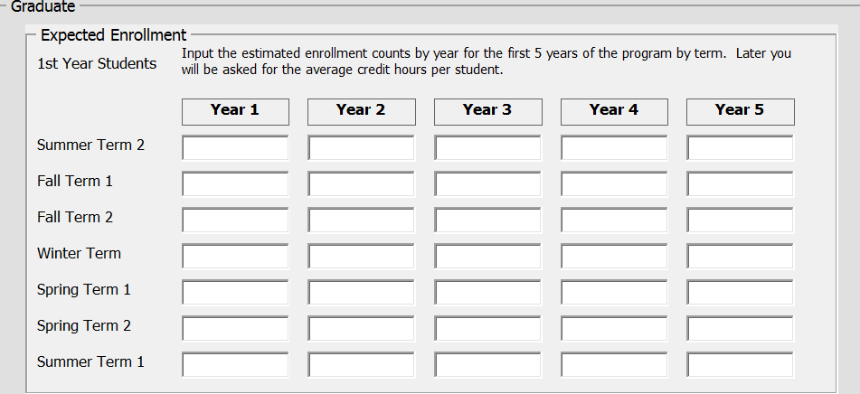

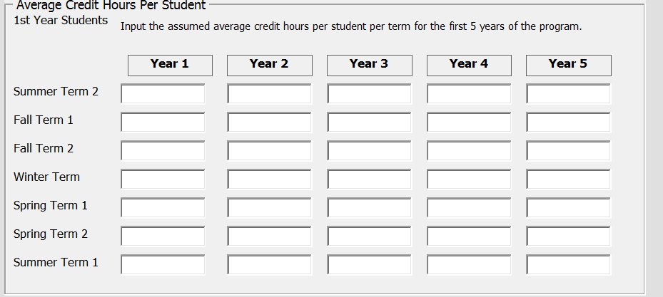

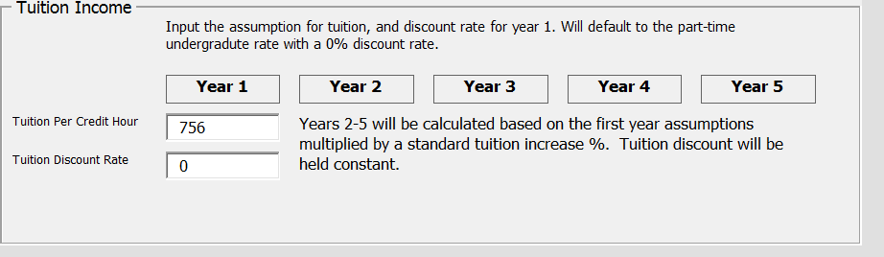

- Certificate Program - Flat Rate
  - Expected enrollment counts by year for the first 5 years of the program, by term if known
  - Certificate revenue per student
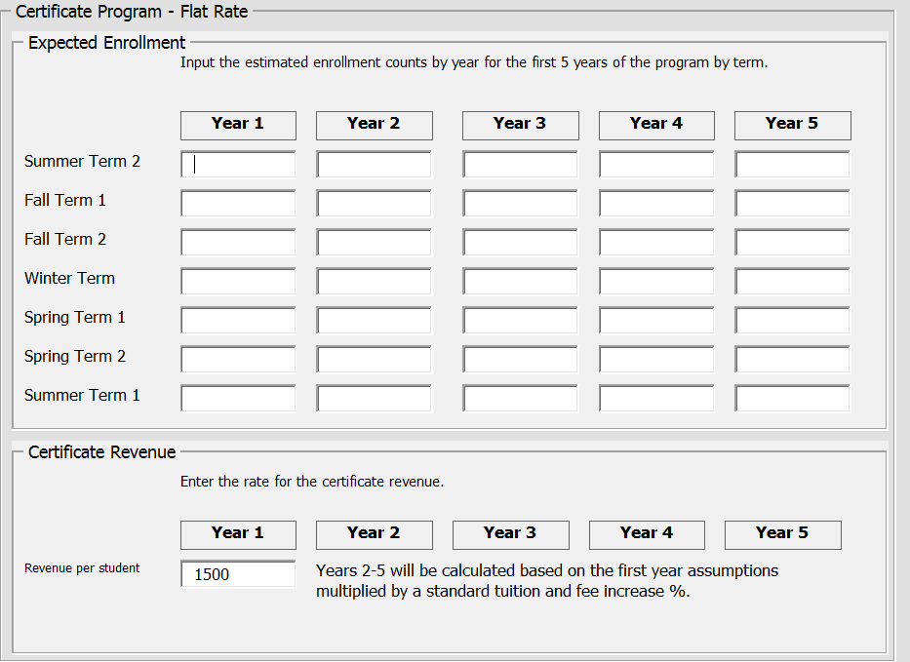

- Certificate Program - Credit Hour Based
  - Expected enrollment counts by year for the first 5 years of the program, by term if known
  - Average Credit Hours Per Student
  - Tuition per credit hour (current base is $756, next fiscal year’s base for graduate is estimated to be $780).
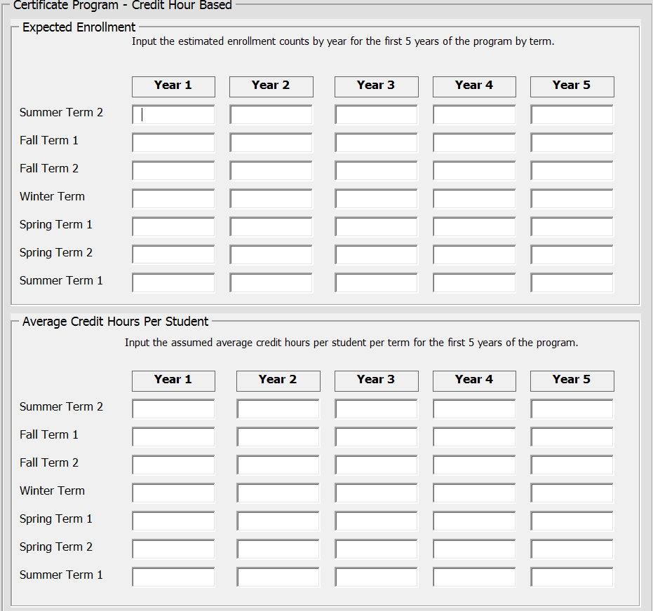
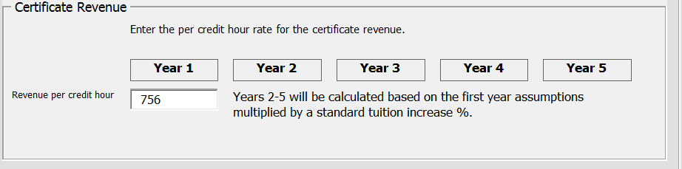
- Other Revenue
  - Endowment income by year
  - Gift income by year
  - Other revenue by year
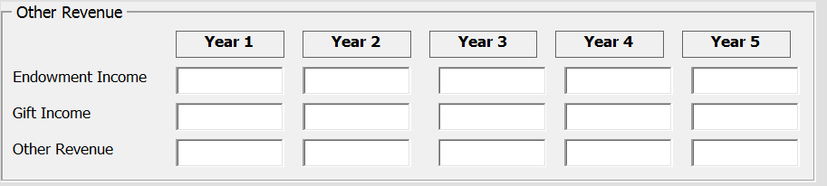
If you have more than one source of revenue, it can be entered by using the Program Type drop down arrow and choosing the appropriate revenue type.
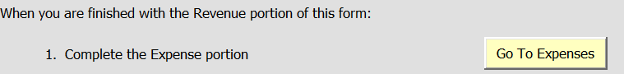When the revenue is completed, enter the expenses clicking the Go To Expenses button and key all information that pertains to the new and/or expanded program for five years.
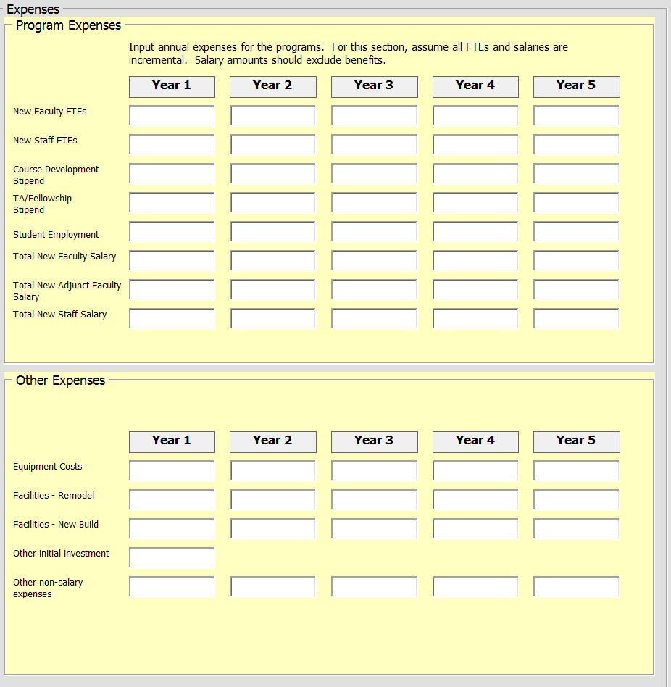

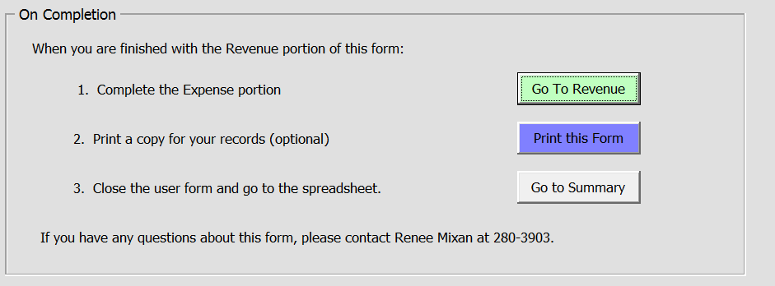
If necessary, you can click the Go To Revenue button to go back to the revenue entry section.
When this form is completed, you can Print this form or Go to Summary which will take you to the summary tab of the spreadsheet. 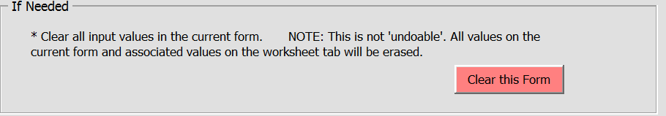
You can also Clear the form by clicking on the appropriate button. Warning: the Clear button will clear all assumptions from the input form and you cannot undo it.
Once the revenue and expense input forms have been completed, close the input form by clicking the grey Go to Summary button. This will take you to the summary tab on the spreadsheet.
The financial projection generated is designed to include your key assumptions as well as annual tuition increases, marketing costs, instructional supplies costs, administrative overhead, payback period, etc.
If after reviewing the summary, there is information that is missing or incorrect, click on the tab at the bottom of the spreadsheet named Input Form and go through the process above to adjust any information. The summary form will be up-dated.
When finished, go to file, save as on the summary tab and save your spreadsheet. 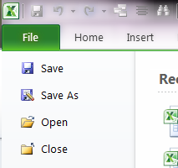

The summary tab is what you need to include for review with the new program proposal.

