As the new Director of the Health Administration and Policy Program, I am happy to welcome you all back to campus and to the HAP community. Last spring, I met with outgoing HAPSA officers Ashley Lehman, Lauren Wong and current HAPSA president Olivia Shope to learn more about the program and student group. This meeting was very helpful to me in understanding student initiatives and concerns. All three continued to help me over the summer with things like senior exit interviews and finding documents from the previous year. Since starting with the program in May, I have made a few changes such as streamlining the major application requirements and process and updating the HAP brochure. I have been working with people on the HAP Advisory Group to investigate how we can improve our course offerings in terms of informatics, and with Development in trying to partner in some way with companies such as Epic Systems, to benefit students. This semester HAP will sponsor a public lecture by Kathleen Rapp, focusing on her experience at AARP directing an education campaign explaining the Affordable Care Act, and will work with HAPSA to bring in other speakers on topics of professional development and graduate school. This spring, the HAP Program will undergo a program review, during which outside experts evaluate the strengths of our program and suggest ways we can improve it. We hope to streamline the major a bit even as we add an additional informatics component. In closing, I would ask all students planning to enroll this spring in the HAP 485 Internship class to contact me ASAP to discuss internship arrangements. I hope to meet you all at some point during the year; my office hours in Hixson Lied G09 are MWF from 1-3 (or other times by appointment). I hope, too, that the new academic year has begun well for you!

**Dr. Christina Clark, Program Director**

This summer I had the opportunity to do an internship through the Alegent Creighton Health system at the McAuley Center. I worked within the Change Management department, with most of my coworkers being Industrial Engineers. This department was neat because it played a role in project improvements in all eleven hospitals, as well as the clinic locations of the Alegent Creighton Heath system. I was exposed first-hand to many of the crucial changes going on in the hospitals and was allowed to sit in many interesting meetings. Some of my projects included a two-week time trial in a clinic to measure patient wait times, helping on the Catholic Health Initiatives transition project, and compiling data for project managers. In addition, the department taught Lean courses for each campus. Lean is a program to maximize customer value while minimizing waste. I was able to complete the eight-course training over my time there the summer. Overall, this internship was fantastic experience. I admired all my co-workers talent and drive, and their willingness to let me jump right in as another team member. They all truly embrace the “Patient First” mentality and set a great example for the entire system.

# Introducing Dr. Christina Clark

When I arrived at Creighton University three years ago, I was waiting for the inspiration to help me answer some of the pivotal questions on every freshman’s mind: “What do I want to major in?”, “What do I want to do for the rest of my life?” and “What can I do to make the most out of my Creighton career?” It hit me the next year while sitting in HAP 200 and considering the nonclinical side of healthcare. I felt that here in HAP is where I can succeed, here is where I can figure out my true interests in healthcare, and here is where I can one day make a difference with everything that I’ll learn along the way.

The mission of HAPSA is to bring students together who share a common interest in the area of healthcare administration in order to promote the exchange of knowledge and facilitate growth in the students’ academic and professional careers. To be serving as HAPSA’s President this year is an opportunity for which I am truly grateful. I believe that this is a unique program on Creighton’s campus with great potential to continue to grow and develop. I am excited to have the chance to introduce students to unique perspectives and opportunities in healthcare while we all work to uncover our true potentials. This year’s HAPSA Executive Team is full of great ideas that I hope will strengthen HAPSA’s campus presence. It should be an exciting year! We hope you’ll reach out to HAPSA throughout the year and allow us to live up to our mission by becoming the best resource for YOU as a HAP student. I wish you all the best of luck this school year!

**Olivia Shope, *HAPSA President***

Inside This Issue

1 A Word from our President

1 Introducing Dr. Christina Clark

2 The HAPSA Exec Team

3 Internships and Experiences

4 Career Spotlight

**Upcoming Meetings:**

Class Registration Advising

Nov. 7 at 6:30 p.m.

HLSB 523

Tom Macy

Nov. 21 at 3:30 p.m.

HLSB 361

Kathleen Rapp

Nov. 22 at 3:30 p.m.

Skutt 105

Air Force Recruiter

MSgt Dawn Roznos

Nov 25 at 4:00 p.m.

HLSB 408

Health Administration and Policy Student Association (HAPSA)

Creighton University

HAPSA news

November 2013

Volume 1 Issue 1

# A Word from our President…

# The HAPSA Executive Team

In case you missed our first meeting when we introduced ourselves, here is some information about us. Please feel free to contact any of us if you have any questions!

*Olivia Shope*

*President*



*HAP major*

*Public Health and French minor*

*Anne Marie Stonikas*

*VP of Programming*

**

*HAP major*

*Public Health and Business minor*

*Samantha Capelli*

*VP of Membership*



*HAP major*

*Pre-Medicine*

*Anna Balling*

*VP of Marketing and Administration*



*HAP and Spanish major*

*Pre-Physical Therapy*

*Andrew Daiker*

*VP of Information Technology*

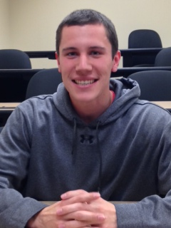

*HAP major*

*Business certificate*

*Ashley Mammen*

*VP of Finance and Alumni Relations*

**

*HAP major*

*Business minor*

# Student Perspectives:

# Two experiences with Alegent Creighton Health

***Courtney Sawle***

***Junior***

***Anne Marie Stonikas***

***Junior***

I am currently the Department Secretary for the Center for Nursing at Alegent Creighton Health. I started last month and my desk is in the McAuley Center, but I have already spent time at Bergan Mercy Medical Center doing training with performance based data management systems. In McAuley, I do a lot of transposing research databases for a project on nursing performance. I also collect and edit information for Alegent Creighton Health's Required Clinical Reading, which is sent out once a week to anyone working for Alegent Creighton Health on the clinical side. Aside from that, I do not do many things consistently, just whatever random tasks the women in the department have for me! I absolutely love all of my coworkers, most of them are ex-nurses so they are all very caring. The only thing I don't like is that it is about a twenty minute drive out to McAuley, but I definitely think it's worth it. What have I learned? Well, SO MUCH. I already learned a ton about the culture of the business/nonprofit world, and many internal issues and successes that I do not feel comfortable sharing. The whole experience so far has been very positive and I would encourage anyone to try and get involved with Alegent Creighton Health. They are experiencing a lot of change with sponsorship being completely handed over to Catholic Health Initiatives, which presents a lot of exciting opportunities to learn from a student's perspective (integration techniques, pros and cons). An easy way is to start is volunteering at CUMC.



# Career Spotlight:

# Discovering a different facet of Health Care Administration

***Karen Caterino is Vice President, National Sales with Healthcare Solutions. She has over 13 years’ experience in the fields of risk management, workers compensation, group health benefits and wellness. Prior to joining Healthcare Solutions, Karen was the Risk Manager for the State of Nevada managing a $40 million dollar fund with over $2 billion in property assets. During her career, she has presented at several national workers compensation and benefit conferences, served on a number of boards and commissions, and was awarded the LexisNexis 2010 Most Notable Persons in Workers’ Compensation-Risk Manager Award. Karen has an undergraduate degree in Sociology, a Master’s in Business Administration, an Associate in Risk Management-Public Entity and is a Certified Government Benefits Administrator and Certified Public Manager ®.***

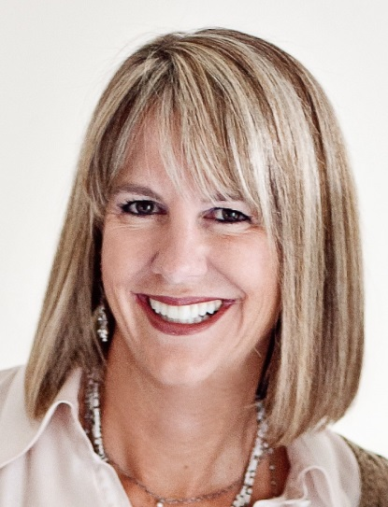

I’m often asked how I became involved in the field of risk management. And I have in turn asked my colleagues the same question. The answer for most of us is the same that is we just “fell in to it.” I am not one to proceed without a plan or purpose and my path to my current career was rather circuitous. However, I wished I had discovered the adventure and excitement of risk and insurance much sooner. I believe it to be an amazing industry of innovative people and daily problem solving that keeps us engaged, excited to be at work and rewarded for a job well done.

Risk Management by definition is *the forecasting and evaluation of financial risks together with the identification of procedures to avoid or minimize their impact.* Not very sexy sounding right? However think about the risks an employer faces every day...workers hurt on the job, equipment damaged in a storm, being sued for an employee’s misconduct or wrongful termination, building collapse, a computer glitch interrupts or shuts down a business, workplace shooting, the list is endless of daily risks faced by businesses. How will the employer pay for such events? Better yet, what more can the employer do to prevent such events from happening in the first place. Welcome to the exciting world of risk management!

Every day, an employer faces a multitude of risk. It’s never a question of if something will happen, but when and how do you manage the aftermath. The employer must decide how to pay for that event and determine how to prevent future occurrences. Risk Managers assess the workplace threats, develop programs to contain the cost of the loss and know how to utilize risk financing tools to pay for losses after they occur.

Simply put, good risk managers save employers money. Risk managers possess a skill set that typically includes being an excellent communicator, analytical problem solver, enjoys working in the unusual and is not cautious of new ideas or guidelines. There are so many jobs within our industry, the list is limitless...defense attorney, nurse case manager, claims adjuster, insurance broker, underwriter, insurance sales person, benefits administrator, risk manager or safety trainer. Be sure to more closely examine opportunities in the field of risk management, I believe you will find a career that is exciting, financially rewarding, continuously evolving and always challenging.