Voting Behaviors
Toward Third Parties
In the 2004 Election

Tim Lindberg
University of Minnesota Morris

In 2000, Ralph Nader became the second third-party candidate in the past three elections (Perot in 1992 and 1996) to affect the outcome of a Presidential race by garnering enough votes and turning out a number of possible non-voters. By 2004 Nader’s name itself seemed to be a curse word in political discourse. Despite people proudly wearing buttons proclaiming, “Anyone But Bush,” they were still not willing for that “Anyone” to be Nader. Voting for Kerry was seen to be the only practical way of making your vote count if you were opposed to George Bush being in office. Seemingly the “two-party tyranny” espoused by Lisa Disch was moving into full swing, denouncing anyone who supported a third-party candidate (particularly a left-leaning one). Signs endorsing Cobb (the Green party candidate) were rare, Nader signs were nearly non-existent, and the Libertarians, despite a growing popularity found very little electoral support. In the final tally, Nader ended up with only 400,706 votes nationally, compared to his 2,882,955 votes in 2000, when his 3% of the vote was much larger than the margin of victory in the popular count. This article is an effort to examine what effect, if any, the backlash against Nader, within the framework of third-party voting in general, had on voter behavior in the 2004 election.

History of Third-Parties in the United States

Let’s first examine third parties, their history in United States Presidential politics, and why people vote for them at all. This overview of third-party politics in Presidential campaigns is important for setting up third-party voting as well as the institutional obstacles they face in American politics.
Although American politics have been a two-party system almost since the inception of the country, it did not begin that way. The first two elections were undisputed wins by George Washington, who rode his popularity as a Revolutionary general to victory. Afterwards Washington stepped down, opening up the Presidency for a two-party race, something that would never be seriously challenged again, despite numerous interesting entries. The Federalists and the Jeffersonians competed in 1796 in the first disputed Presidential election. In 1804, the first Presidential caucus occurred. It was not until 1824 that no candidate (there were four who garnered electoral votes) received a majority of the Electoral College, thus sending the decision to the House of Representatives.
The first foray for a third-party candidate occurred in 1848. Martin Van Buren, a former President, ran under the Free Soil Party banner and ended up with 10% of the total vote. The most important factor in his electoral bid is that the votes he garnered secured the election for one of the major party candidates. Finally, in 1892, James Weaver, running for the Populist Party, became the only third party candidate between the Civil War and World War I to actually carry a state, although he only received 8.5% of the vote. In 1896, William Jennings Bryan, under both the Democratic and Populist banners fought a two-candidate battle, but lost. Third-party voting decreased until 1940, when only .4% of all votes went to a candidate not of the two dominant parties.
In 1948 Strom Thurmond received 39 electoral votes and nearly 1.2 million votes. Henry Wallace also received over a million votes that year, running for the Progressive Party. Combined with other third-party candidates, they garnered over 5% of the total vote. It would not be until 1968, however, that a third-party made any sort of impact in a Presidential election. That year, in an election that would be decided by less than 125,000 and .7% of the votes, George C. Wallace, running for the American Independent Party, managed to get 46 electoral votes and 13.5% of the popular vote.
In the 1990’s Ross Perot would stir up the world of Presidential politics in both the 1992 and 1996 elections. In 1992, Perot received 19% of the popular vote and in 1996 he got 8% of the popular vote. Perot never received an electoral vote, but both of his campaigns did have an effect on the two major candidates’ campaigns. Then, in 2000 came what has become the largest controversy in third-party politics in Presidential elections. Ralph Nader, running as a Green party candidate, in a race decided by just more than a half million popular votes and five electoral votes, received 2,882,955 popular votes. The controversy came when in Florida that year, Bush, needing to win the state to secure his election, came out less than 2,000 votes ahead of Gore. Nader got nearly 100,000 votes in Florida. This led to a flurry of scholarly activity on whether Nader actually affected the election. To be fair, there were four other third-party candidates in Florida who received more votes than the margin of victory. Finally, this past fall, Nader, felt a backlash of support, and only received a little over 400,000 votes, just 1% of the total and not enough to affect the popular outcome. With this background in mind I will now move on to examine the current third party literature.

Literature Review

As previously mentioned, there are two ways to investigate the effects of third parties within elections. The first looks directly at the third parties themselves - Who votes for them, the candidates, the issues etc. The second examines the various obstacles that third parties face both institutionally and within the electoral system. While both of these schools of thought are seemingly intertwined most authors only specifically consider one of them at a time.

Third Parties: What are they?
In their book, Multiparty Politics in America, Herrnson and Green examine four types of third-parties within the historical framework of the United States. The first is “Enduring Comprehensive Parties,” which attempt to mirror the major parties of the time. They tend to be small and influential on state or occasionally regional elections. For example, “The American (or Know-Nothing) Party won control of the Massachusetts governorship and both chambers of the state legislature in 1854 (19).” The authors describe enduring minor parties as any which achieve electoral success over multiple elections. These types of minor parties have dwindled in importance as it has become more and more difficult to persuade former strong candidates of the major parties to run under a third-party banner.
This leads us to Herrnson and Green’s second type of minor party: the candidate focused party. These parties are not created to mirror a major party, but simply to forward an attractive candidate. They usually do not last longer than two elections, since they depend entirely on that candidate’s popularity. Ross Perot, in 1992 and 1996, garnered a respectable number of votes, but his party is now inactive in American politics. In 1912, Roosevelt, after not receiving the GOP nomination, created a party to run for President, which led to a Democratic victory. In 1916, the Republican leadership convinced Roosevelt to return to the party and his third-party died (20).
The third type of third-parties is the single-issue party. These parties rally support around a “salient, highly charged cause or related set of causes (23).” Given that elections are highly visible political atmospheres, these parties attempt to ride that visibility to garner more awareness and support for a specific issue or set of issues. The Green party is an example of this party, although Nader’s national success is based more upon his popularity than the party’s platform. Still, the Green party has managed to win a number of local elections throughout the country. The New York state Right-to-Life party is another example of an issue party. Dealing solely with anti-abortion issues, this party has used its issue attention to support candidates with the same views.
This leads to Herrnson and Green’s fourth type of third-parties: fusion parties. Fusion is the act of having a single candidate receive endorsements from more than one party, and therefore have his or her name on more than one ballot line. While this practice has been outlawed for decades in most states and in national elections, there are still a number of states who allow its practice, most visibly New York. In New York there are a number of stable minor-parties which routinely help a candidate win an election by cross-endorsing them. In fact, “Of the fifty-seven major-party candidates who ran for Congress in 1994, thirty-six were cross-endorsed by one of New York’s minor parties (24-25).” These four types of party are important to understanding why third parties fail: they find it very difficult to fulfill a role while also becoming politically viable and successful.
Support for third-parties rises and falls “in response to national conditions, the performance of the two major parties, and the effects of the minor parties themselves (25).” Minor parties do well under poor economic conditions, particularly agriculturally, and may also have an impact when the two major parties fail to address an important issue (25). Finally, as stated before, third-parties can enjoy more success by nominating a popular candidate, such as Nader for the Greens in 2000.
Perhaps the most important facet of third-parties is why people do or do not actually vote for them. According to Green (61, Herrnson), using Harris Poll and NES data, between 1992 and 1998, 27% of the population would prefer the growth of a multi-party system intent on effectively challenging the dominance of the two major parties over either candidate-focused elections or a continuation of the two-party system. Only 38% preferred the two-party system (61, Herrnson). The author also showed that independent voters, rather than Democrats or Republicans were most likely to “push” for a multi-party system (64, Herrnson). This is extremely important since the number of independents has been increasing over the past half century (324 Table 17-1, Niemi).
Green also examined the reasons for public dissatisfaction with the two-party system. Nearly one-half of all people who preferred the multi-party system had at least one major complaint about the current two-party system (66, Herrnson). When examining who these voters are that prefer a multi-party system Green finds that, “Multiparty Democrats were more liberal, Multiparty Independents more conservative, and the Multiparty Republicans roughly the same as their Two-Party counterparts (69, Herrnson).” At the same time, however, the more liberal multiparty Democrats were actually less likely to support a third-party, thereby limiting the possibilities for a successful “progressive” party. Overall, Green finds that there is a significant amount of support for the creation of a multi-party system in American electoral politics.

Third Party Obstacles
Despite considerable support for third parties, few have actually enjoyed any sort of success, and those that have are frequently short-lived and are centered upon one candidate’s popularity. A number of scholars have looked for causes of this discrepancy and many factors have surfaced. Perhaps the first place to look at is our own political culture. The American political system is ingrained within this country, from the media to our schools. We are taught a two-party existence. Lisa Disch, in her recently published, The Tyranny of the Two-Party System, discusses the reason that actual third party electoral support does not occur:

Powerful arguments could be made in a context where the two-party doctrine did not sanctify major party duopoly as a democratic design. But wherever that doctrine holds sway, where journalists pay homage to its tenets as much as by the stories they refuse to tell as by those they publish, where academics pay lip service to the two-party system, and where voters take it for granted, the very culture of common sense silences those arguments (20, Disch).

While not as impassioned, Dwyre and Kolodny, in their examination of barriers to minor party success, note three cultural obstacles. The first deals with the definition of democracy. At the core of the American definition of democracy is the idea of majority rule, a “winner takes all” attitude. Without a redefinition of democracy that includes the possibility of proportional representation, coalition governments, etc. there will be little support in elections for minor parties (162, Herrnson). The second cultural barrier is that of entrenchment. The two-party system is so dominant that voters must work within the structure or risk “wasting their vote” on a third-party candidate. The permeability of the two major parties also gives rise to the idea that they can adapt to the opinions of the majority of voters, despite the low likelihood of this being effective given the diversity of opinions (162, Herrnson). The third factor deals with the plausibility of minor parties as an alternative to the two-party system. Since most voters don’t think of third parties as viable options for electoral success they are unlikely to support them at the polls, no matter what their views on a multi-party system are (162, Herrnson).
Disch adds another factor in two-party dominance. She claims that the scholars of political science are just as much to blame as any other factor for denying access to third-party candidates.

The two-party system is more than a name for a thing. A concept that we invoke casually, as if it did no more than name a feature of our reality, it forms the very fields to which it seems only to refer. The linchpin for a complex of observed facts regarding the inevitability of third-party failure, and deep-seated beliefs about the superior accountability and stability of two-party democracies, it serves both to orient action and to organize a field of knowledge. In short, the two-party system is a catchphrase (59, Disch).

As examples of this scholarly bias, in their investigation of voter recall, Lodge and Steenbergen, use only two candidates in a race, one Democrat and one Republican (240, Niemi). Lau and Redlawsk, examining what they call “voting correctly” use only two candidates, again one Democrat and one Republican (139, Niemi). Most academic study done of electoral politics solidifies the two-party system as the system in American politics.
Cultural biases are not the only obstacles for minor parties to overcome. There are an incredible number of legal and institutional barriers as well. The most overlooked, but oftentimes most important piece of political parties is the actual definition. For example, when Minnesota lawmakers were debating the use of fusion after a challenge to its legality in the 1990’s, “they were surprised to discover no definition of a minor party,” in the statute books. “There were access thresholds for putting an alternative candidate on the ballot, but these did not constitute a definition (23, Disch).” In terms of ballot access, every state and the District of Columbia all have separate definitions for political party. The only faintly national definition of parties is within the “campaign finance regulations…These national definitions are not favorable to minor parties (163, Herrnson).”
Beyond just their definition, minor parties face incredible legal hurdles. Voter registration in many states requires minor parties to gather an incredible amount of signatures for a party that doesn’t exist. Many states also close registration thirty days prior to an election (164, Herrnson). Those states that have same-day registration (Maine, Minnesota, New Hampshire, and Wisconsin) frequently record higher voter turnouts and larger voting percentages for third-party candidates. Another hurdle is ballot access. In most states parties that receive a certain percentage of the vote in an election are not required “to collect signatures or expend any other effort to remain on the ballot (164, Herrnson).” Illegalized fusion also works as a barrier for minor party influence. “Fusion makes it easier for minor parties to realize some success because fusion tickets allow citizens to vote for a minor party without feeling they have wasted their vote (165, Herrnson).” The Supreme Court of the United States ruled in Timmons et al v. Twin Cities Area New Party in 1997 that a state law against fusion was constitutional. In that case the assistant solicitor general of Minnesota argued that, “the state forbids fusion to prevent voter confusion and to guard against ballot manipulation (166, Herrnson).” Disch asserts, however, that fusion “opened up options for parties and voters…citizens could cast a protest vote without ‘wasting’ a ballot or contributing indirectly to the victory of their least favorite establishment party candidate (39, Disch).”
Perhaps the greatest impediment to third-party success, however, is simply the American electoral system. On the Presidential level, the popular vote does not decide the President. As recently as 2000, a President was selected without receiving a majority of the popular vote. This setup, where a candidate must win an entire state to receive any “real” electoral winnings, is a major hurdle for minor party candidates. Ross Perot, as a third-party candidate in 1992 received nearly 20 million votes, but in effect, received nothing, because he did not garner a single electoral vote. In contrast, George Wallace in 1968, who received a much smaller percentage of the total vote, actually did better than Perot, since he won a number of Southern states. With a system of proportional representation, Perot would have gotten approximately 102 electoral votes in 1992, and Clinton would not have received a majority of the electoral votes, thus throwing the election decision to the House of Representatives (167, Herrnson). The Electoral College is simply the physical representation of a dominating “winner-takes-all” system that is widespread in American politics.
Dwyre and Kolodny also describe two other barriers, both institutional. The first is campaign finance. The Federal Election Campaign Act (FECA) gives public funding to major party candidates, defined as those who party received 25% or more in the previous presidential election. For minor party candidates, those receiving between 5 and 25% of the previous total, they can receive some public funding. Finally, for new parties, they can only receive public funding after the election and only if they receive at least 5% of the vote (168, Herrnson). The other institutional hurdle they discuss is that of the media. Third-party candidates are basically ignored by the media. In cases where they do receive exposure, it is usually negative. They are also frequently barred from presidential debates and their conventions rarely receive media coverage. Overall, third-party candidates have trouble finding free media and usually do not have the resources to get paid media (170, Herrnson). Media could provide better coverage of third parties, but it would require a drastic change in current practices.
An example that shows the effects of loosened barriers for minor party success is Jesse Ventura’s 1998 gubernatorial campaign in Minnesota. Ventura, a minor party candidate was a former pro wrestler and mayor of a Minneapolis suburb. He enjoyed name recognition and the press mostly ignored him at the beginning. Due to his party label, he did not have to go through any extra effort to get on the ballot. In fact, Ventura was listed first on the ballot because of Minnesota law. He was automatically included in gubernatorial debates as well and “Ventura received through generous state campaign finance laws over $300,000 that he used to buy television advertising time (95, Lentz).” Near the end of the campaign, the press began to notice Ventura, but instead of receiving negative press, many of the stories were positive and contributed to his growing popularity. Finally, Minnesota’s same day registration gave Ventura the ability to have a late surge in popularity actually equate to votes at the polls.
As previous research indicates, minor parties and their candidates face tremendous institutional, cultural, and historical barriers. For a minor party to succeed, not only would laws and regulations need to change, but also our ideas about the political system we utilize in the United States. While I will not directly touch upon a number of these previously mentioned barriers, it is important to realize how deep the discrimination of third parties and the domination of the two-party system sink into the American political construction. This depth of discrimination in general is what I am attempting to show in this study.

Hypothesis

Through statistical analysis of an exit survey of the 2004 Presidential election, I hope to find evidence of two-party dominance as well as the restraints that are placed upon the success of third parties. Third parties are institutionally and culturally discriminated against in the American political system. I believe the data will show that third parties, in voter’s views, are seen as unviable options or a “wasted vote.” It will also show that most voters do not even consider third parties as politically existent. I expect to find that the dominant view of the two-party system is prevalent in the minds of American voters and has an effect on people’s voting behavior, especially attitudes toward third parties.

Methods

In a discussion such as this it is important to use more than one way to examine third-party political effects. Most political scientists to this point, however, have looked at third party failure and the two-party system dominance as separate. There are restraints on third parties becoming politically successful, but there are also reasons why the two-party system would not allow a third party to exist even without these restraints, namely two-party dominance. [In these terms, two-party dominance is the aggregate power which the Republican and Democratic parties hold over the political system, including voting, policy-making, media framing and so forth] Desiring to fulfill both of these aspects of the political system, I propose to study two types of questions. One is to ask questions specifically regarding third-party behavior, beliefs, and voting. The other is to examine the two-party system’s dominance in political thought and culture.
Utilizing exit polling completed during Election Day 2004, I will be using a number of questions from the survey covering a broad range of levels of third-party support or two-party dominance. Most of the statistical methods used are simple cross-tabs which are adequate to make conclusions from the survey responses. [For detailed information on the Exit Survey in general, refer to Appendix II.]

Findings

Nader’s impact on Third-Party Voting
The first responses I examined were those to the question: After Ralph Nader’s 2000 presidential campaign, are you more or less likely to vote for a third-party candidate? I completed simple cross-tabs with the vote choices for the 2004 Presidential race (Table 1), the 1998 Minnesota gubernatorial race (Table 2), and party identification (Table 3). The most noticeable aspect of these three cross-tabs is the effect that Nader had upon Democratic voters. Among those who voted for Kerry in 2004, 45.2% said that Nader’s campaign in 2000 made them less likely to vote for a third party candidate (Table 1). That same percentage was 60% among those who voted for Humphrey (DFL gubernatorial candidate) in 1998 (Table 2) and 51.4% among those who identify with the Democratic Party (Table 3). To compare to the Republican counterparts those same percentages were 20% (Table 1), 29.2% (Table 2), and 21.4% (Table 3). Another interesting factor is that in the 2004 election, of those who voted for either Cobb or Nader, five of nine were more likely to vote for a third party candidate and the last four it had no impact (Table 1). This is in stark contrast to those who voted for Ventura in 1998. Those voters were more likely to have Nader be a negative impact on third party voting (31.4%) than a positive (21.6%), although nearly half (47.1%) said Nader had no impact upon their vote (Table 2).

Table 1: Cross-Tabulation of the Impact of Nader and the 2004 Presidential Election

 |  |  | Vote in 2004 Presidential Election |  |  |  |  |  |  | Total
 |  |  | Bush | Kerry | Nader | Cobb | Other | Did Not Vote | No  Resp. | Total
Impact of Nader | Much more or somewhat more likely | Count | 10 | 42 | 2 | 3 | 0 | 1 | 3 | 61
Impact of Nader | Much more or somewhat more likely | % within pres2004 | 10.5% | 16.1% | 100.0% | 42.9% | .0% | 50.0% | 42.9% | 16.1%
Impact of Nader | No Impact on vote | Count | 66 | 101 | 0 | 4 | 3 | 1 | 1 | 176
Impact of Nader | No Impact on vote | % within pres2004 | 69.5% | 38.7% | .0% | 57.1% | 75.0% | 50.0% | 14.3% | 46.6%
Impact of Nader | Much less or somewhat less likely | Count | 19 | 118 | 0 | 0 | 1 | 0 | 3 | 141
Impact of Nader | Much less or somewhat less likely | % within pres2004 | 20.0% | 45.2% | .0% | .0% | 25.0% | .0% | 42.9% | 37.3%
Total |  | Count | 95 | 261 | 2 | 7 | 4 | 2 | 7 | 378
 |  | % within pres2004 | 100.0% | 100.0% | 100.0% | 100.0% | 100.0% | 100.0% | 100.0% | 100.0%

Table 2: Cross-Tabulation of the Impact of Nader and the 1998 Minnesota Gubernatorial Election

 |  |  | Vote in 1998 Gubernatorial Election |  |  |  |  |  | Total
 |  |  | Coleman | Humphrey | Ventura | Other | Did Not Vote | No Resp. | Total
Impact of Nader | Much more or somewhat more likely | Count | 2 | 9 | 11 | 1 | 33 | 5 | 61
Impact of Nader | Much more or somewhat more likely | % within guv98 | 4.2% | 15.0% | 21.6% | 100.0% | 17.5% | 17.2% | 16.1%
Impact of Nader | No Impact on vote | Count | 32 | 15 | 24 | 0 | 94 | 11 | 176
Impact of Nader | No Impact on vote | % within guv98 | 66.7% | 25.0% | 47.1% | .0% | 49.7% | 37.9% | 46.6%
Impact of Nader | Much less or somewhat less likely | Count | 14 | 36 | 16 | 0 | 62 | 13 | 141
Impact of Nader | Much less or somewhat less likely | % within guv98 | 29.2% | 60.0% | 31.4% | .0% | 32.8% | 44.8% | 37.3%
Total |  | Count | 48 | 60 | 51 | 1 | 189 | 29 | 378
 |  | % within guv98 | 100.0% | 100.0% | 100.0% | 100.0% | 100.0% | 100.0% | 100.0%

Table 3: Cross-Tabulation of the Impact of Nader and Party Identification

 |  |  | Party Identification |  |  |  |  |  | Total
 |  |  | Rep. | Dem. | Ind. | Other | Multiple | No Resp. | Total
Impact of Nader | Much more or somewhat more likely | Count | 9 | 29 | 16 | 5 | 0 | 1 | 60
Impact of Nader | Much more or somewhat more likely | % within  ptyidnes | 12.9% | 13.8% | 24.2% | 18.5% | .0% | 33.3% | 15.9%
Impact of Nader | No Impact on vote | Count | 46 | 73 | 38 | 17 | 0 | 2 | 176
Impact of Nader | No Impact on vote | % within ptyidnes | 65.7% | 34.8% | 57.6% | 63.0% | .0% | 66.7% | 46.7%
Impact of Nader | Much less or somewhat less likely | Count | 15 | 108 | 12 | 5 | 1 | 0 | 141
Impact of Nader | Much less or somewhat less likely | % within ptyidnes | 21.4% | 51.4% | 18.2% | 18.5% | 100.0% | .0% | 37.4%
Total |  | Count | 70 | 210 | 66 | 27 | 1 | 3 | 377
 |  | % within ptyidnes | 100.0% | 100.0% | 100.0% | 100.0% | 100.0% | 100.0% | 100.0%

The Republican voters were also much more likely for Nader to have had no impact upon their vote at all. Among those identifying themselves with the Republican Party, 65.7% said Nader had no impact on their vote (Table 1). 66.7% of those who voted for Coleman in 1998 said he had no impact as well (Table 2) and for Bush voters that percentage was 69.5% (Table 3). Finally one last variable to note is that with voters who identify themselves as independents, they are the most likely for Nader to have had a positive effect upon (24.2%) as compared to those with a negative effect (18.2%) (Table 3).
The last thing to look at is age (Table 4). The most noticeable thing here is that as age increases, the likelihood that Nader’s campaign had a positive effect goes down, until 50% of those 61 or over are less likely to vote for a third party candidate because of Nader.

Table 4: Cross-Tabulation of the Impact of Nader and Age
 |  |  | Age |  |  |  |  | Total
 |  |  | 18-30 | 31-44 | 45-60 | 61+ | No Resp. | Total
Impact of Nader | Much more or somewhat more likely | Count | 41 | 7 | 7 | 3 | 2 | 60
Impact of Nader | Much more or somewhat more likely | % within bddatedivisions | 18.1% | 11.7% | 12.5% | 11.5% | 22.2% | 15.9%
Impact of Nader | No Impact on vote | Count | 107 | 31 | 25 | 10 | 3 | 176
Impact of Nader | No Impact on vote | % within bddatedivisions | 47.3% | 51.7% | 44.6% | 38.5% | 33.3% | 46.7%
Impact of Nader | Much less or somewhat less likely | Count | 78 | 22 | 24 | 13 | 4 | 141
Impact of Nader | Much less or somewhat less likely | % within bddatedivisions | 34.5% | 36.7% | 42.9% | 50.0% | 44.4% | 37.4%
Total |  | Count | 226 | 60 | 56 | 26 | 9 | 377
 |  | % within bddatedivisions | 100.0% | 100.0% | 100.0% | 100.0% | 100.0% | 100.0%

Priming with “Debacle” and “Results”
Following this same statistical methodology for the other two priming questions, one replacing “Nader” with “debacle” and the other replacing “Nader” with “results” much of the same results are found. On each of the questions the n is considerably smaller, since they were only on one of the surveys as compared to the “Nader” version which was on two. Many of the same conclusions can be drawn. Democrats were more likely than Republicans, on either question, to have their likelihood of voting for a third-party decreased. Tables 5 and 6 are cross-tabs of the “debacle” version and the 2004 Presidential election and respondent’s party identification. Tables 7 and 8 are the same cross-tabs for those respondents with the “results” version.
Table 5: Cross-Tabulation of the Impact of Debacle and the 2004 Presidential Election

 |  |  | Vote in 2004 Presidential Election |  |  |  |  |  | Total
 |  |  | Bush | Kerry | Nader | Other | Did Not Vote | No Resp. | Total
Impact of Debacle | Much more or somewhat more likely | Count | 6 | 12 | 2 | 3 | 0 | 4 | 27
Impact of Debacle | Much more or somewhat more likely | % within pres2004 | 13.3% | 9.2% | 100.0% | 75.0% | .0% | 44.4% | 14.1%
Impact of Debacle | No Impact on Vote | Count | 27 | 45 | 0 | 1 | 2 | 3 | 78
Impact of Debacle | No Impact on Vote | % within pres2004 | 60.0% | 34.6% | .0% | 25.0% | 100.0% | 33.3% | 40.6%
Impact of Debacle | Much less or somewhat less likely | Count | 12 | 73 | 0 | 0 | 0 | 2 | 87
Impact of Debacle | Much less or somewhat less likely | % within pres2004 | 26.7% | 56.2% | .0% | .0% | .0% | 22.2% | 45.3%
Total |  | Count | 45 | 130 | 2 | 4 | 2 | 9 | 192
 |  | % within pres2004 | 100.0% | 100.0% | 100.0% | 100.0% | 100.0% | 100.0% | 100.0%

Table 6: Cross-Tabulation of the Impact of Debacle and Party Identification

 |  |  | Party Identification |  |  |  |  | Total
 |  |  | Rep. | Dem. | Ind. | Other | No Resp. | Total
Impact of Debacle | Much more or somewhat more likely | Count | 5 | 7 | 11 | 4 | 0 | 27
Impact of Debacle | Much more or somewhat more likely | % within ptyidnes | 11.9% | 7.6% | 28.9% | 22.2% | .0% | 14.1%
Impact of Debacle | No Impact on Vote | Count | 27 | 29 | 17 | 5 | 0 | 78
Impact of Debacle | No Impact on Vote | % within ptyidnes | 64.3% | 31.5% | 44.7% | 27.8% | .0% | 40.6%
Impact of Debacle | Much less or somewhat less likely | Count | 10 | 56 | 10 | 9 | 2 | 87
Impact of Debacle | Much less or somewhat less likely | % within ptyidnes | 23.8% | 60.9% | 26.3% | 50.0% | 100.0% | 45.3%
Total |  | Count | 42 | 92 | 38 | 18 | 2 | 192
 |  | % within ptyidnes | 100.0% | 100.0% | 100.0% | 100.0% | 100.0% | 100.0%
Table 7: Cross-Tabulation of the Impact of Results and the 2004 Presidential Election

 |  |  | Vote in 2004 Presidential Election |  |  |  |  | Total
 |  |  | Bush | Kerry | Nader | Other | No Resp. | Total
Impact of Results | Much more or somewhat more likely | Count | 3 | 21 | 1 | 2 | 5 | 32
Impact of Results | Much more or somewhat more likely | % within pres2004 | 7.3% | 16.7% | 50.0% | 66.7% | 45.5% | 17.5%
Impact of Results | No Impact on Vote | Count | 26 | 41 | 1 | 1 | 3 | 72
Impact of Results | No Impact on Vote | % within pres2004 | 63.4% | 32.5% | 50.0% | 33.3% | 27.3% | 39.3%
Impact of Results | Much less or somewhat less likely | Count | 12 | 64 | 0 | 0 | 3 | 79
Impact of Results | Much less or somewhat less likely | % within pres2004 | 29.3% | 50.8% | .0% | .0% | 27.3% | 43.2%
Total |  | Count | 41 | 126 | 2 | 3 | 11 | 183
 |  | % within pres2004 | 100.0% | 100.0% | 100.0% | 100.0% | 100.0% | 100.0%

Table 8: Cross-Tabulation of the Impact of Results and Party Identification

 |  |  | Party Identification |  |  |  |  | Total
 |  |  | Bush | Kerry | Nader | Cobb | No Resp. | Total
Impact of Results | Much more or somewhat more likely | Count | 7 | 16 | 6 | 3 | 0 | 32
Impact of Results | Much more or somewhat more likely | % within ptyidnes | 17.5% | 16.0% | 26.1% | 15.8% | .0% | 17.5%
Impact of Results | No impact on vote | Count | 21 | 32 | 8 | 10 | 1 | 72
Impact of Results | No impact on vote | % within ptyidnes | 52.5% | 32.0% | 34.8% | 52.6% | 100.0% | 39.3%
Impact of Results | Much less or somewhat less likely | Count | 12 | 52 | 9 | 6 | 0 | 79
Impact of Results | Much less or somewhat less likely | % within ptyidnes | 30.0% | 52.0% | 39.1% | 31.6% | .0% | 43.2%
Total |  | Count | 40 | 100 | 23 | 19 | 1 | 183
 |  | % within ptyidnes | 100.0% | 100.0% | 100.0% | 100.0% | 100.0% | 100.0%

After examining this data, I ran a t-test between the three questions to see if Nader and results were primes among voters. Table 9 shows the results of the t-test with the inclusion of all respondents who answered that there was “No impact on vote.” Table 10 removes those answers and simply looks at responses of much more, somewhat more, somewhat less, and much less likely on a four point scale.
Looking at this data, it is easy to see that the question with “Nader” or “debacle” instead of “results” were primes as their differences were statistically significant. If responses of “No impact on vote” are included, however, Nader is less of a prime than any other question (Table 9). This intriguing twist can be explained by the enormous amount of respondents who said that Nader’s campaign had not effect on their likelihood to vote for third parties. This response uploaded the question. By removing that response variable, a more valuable evaluation becomes apparent, and it is easy to see that both Nader and labeling the 2000 election as a debacle are primes on third-party voting behavior (Table 10).

Table 9: One-Sample T-Test of Debacle, Results, and Nader including “No Impact on Vote” variable

 | Test Value = 0
 | t | df | Sig. (2-tailed) | Mean Difference | 95% Confidence Interval
 |  |  |  |  | Lower | Upper
Debacle | 43.239 | 191 | .000 | 3.52604 | 3.3652 | 3.6869
Results | 40.759 | 182 | .000 | 3.42077 | 3.2552 | 3.5864
Nader | 59.659 | 377 | .000 | 3.38889 | 3.2772 | 3.5006

Table 10: One Sample T-Test of Debacle, Results, and Nader excluding “No Impact on Vote” variable

 | Test Value = 0
 | t | df | Sig. (2-tailed) | Mean Difference | 95% Confidence Interval
 |  |  |  |  | Lower | Upper
Nader | 42.761 | 201 | .000 | 3.02970 | 2.8900 | 3.1694
Results | 32.010 | 110 | .000 | 2.98198 | 2.7974 | 3.1666
Debacle | 34.380 | 113 | .000 | 3.12281 | 2.9429 | 3.3028

Instant Runoff
The next thing I examined were the responses to the instant runoff voting question, where the survey respondents were allowed to rank, in order, their preference for Presidential candidate. My goal here is to see any effects of major party dominance and which minor parties are the most attractive. Using a graph, where the numbers on the x-axis are simply the spot of preference with one being the greatest. The first thing to notice is that many people did not even answer the question (all responses labeled 99). The only time this is not the case is when looking at the DFL graph, understandable given the bias toward Democrats in our study. Overall, the tendency not to answer leads to an explanation of complexity or disinterest. Either of these possibilities would lend credence toward the two-party dominance. By dividing the nine parties into three different categories other effects begin to appear. The “unknown” minor parties, (Socialist Worker’s, Christian Freedom, Constitution, and Socialist Equality) all have preferences that rise toward the five or six point on the scale. The “known” minor parties (Green, Libertarian, and Better Life because of Nader) all find that same rise between the two and four points on the scale. The two major parties both find their high marks at the ends. One thing to notice is that every party, except the Christian Freedom party, had a least one person who ranked them first. This was especially true with the Better Life party (Nader) which had fifteen first place ranks. Among these respondents Nader only received one vote for President. Thirteen of them were Kerry voters and the lat one did not specify a 2004 Presidential vote choice. This shows that instant runoff voting may have at least some effect on voting behavior.
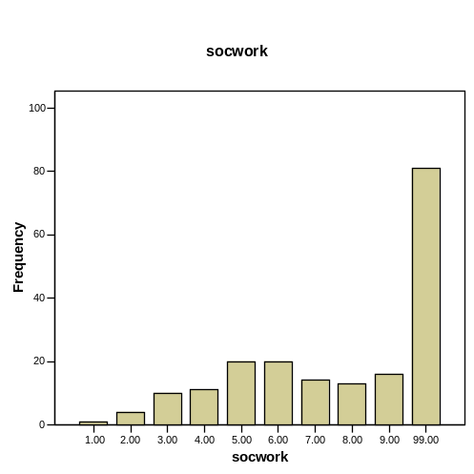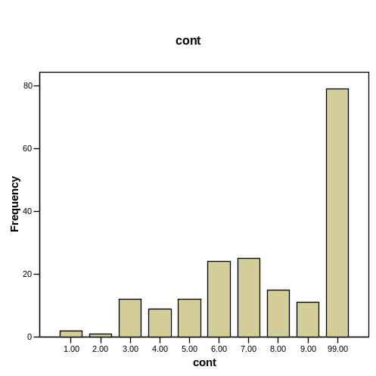
Socialist Worker’s Party Constitution Party
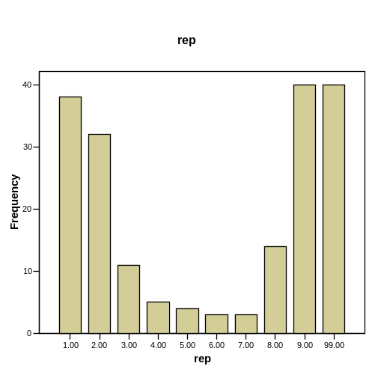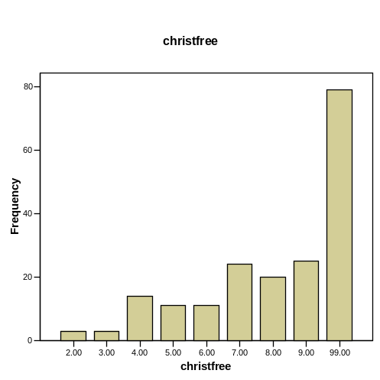
Republican Party Christian Freedom Party
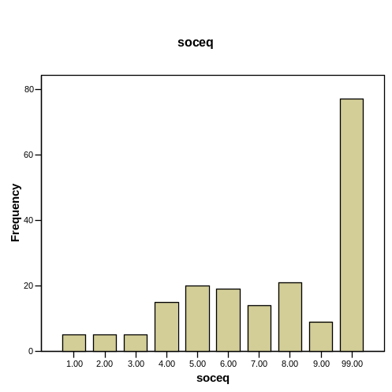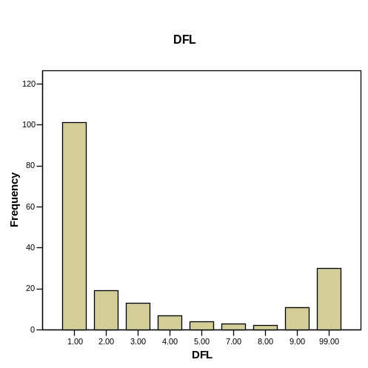
Socialist Equality Party Democratic-Farmer-Labor Party
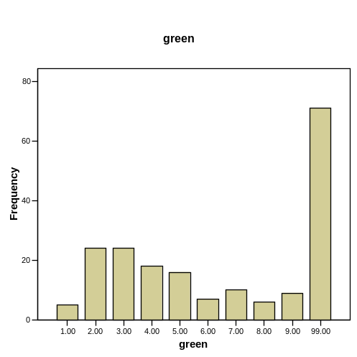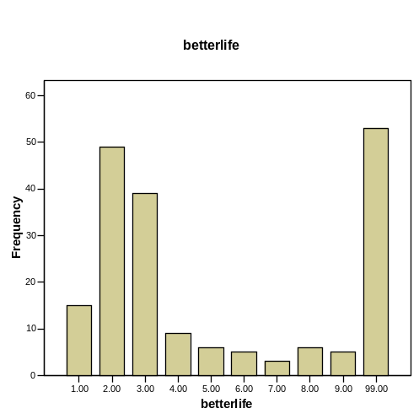
Green Party Better Life Party
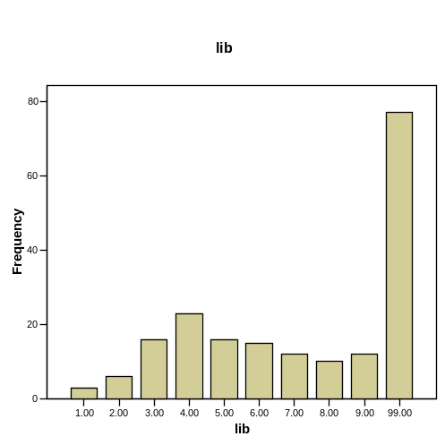
Libertarian Party

Ventura’s impact on Third-Party Voting
The next thing I examined were x-tabs dealing with the impact that Jesse Ventura’s 1998 campaign for Minnesota governor had on people’s propensity to vote for a third party candidate. Referencing the 2004 Presidential Election (Table 11), the 1998 Minnesota gubernatorial election (Table 12), and party identification (Table 13), there are a few notes of interest. Unlike Nader, Ventura’s campaign was much less likely to have an effect on voting for third parties, as most respondents (65.5%) said that his campaign had no effect on their attitudes toward voting for a third party. This is true even among those who voted for Ventura in 1998. Ventura voters in the 1998 election, however, were also the most likely to have their incentive to vote for a third party increased (Table 12). Also, independents were over twice as likely as Democrats or Republicans to have their incentive increased (Table 13).

Table 11: Cross-Tabulation of Ventura’s Impact and 2004 Presidential Election

 |  |  | Vote in 2004 Presidential Election |  |  |  |  |  |  | Total
 |  |  | Bush | Kerry | Nader | Cobb | Other | Did Not Vote | No Resp. | Total
Ventura’s Impact | Increased Incentive | Count | 8 | 32 | 1 | 1 | 0 | 0 | 0 | 42
Ventura’s Impact | Increased Incentive | % within pres2004 | 8.1% | 12.2% | 50.0% | 14.3% | .0% | .0% | .0% | 10.9%
Ventura’s Impact | Decreased Incentive | Count | 27 | 46 | 0 | 0 | 0 | 1 | 0 | 74
Ventura’s Impact | Decreased Incentive | % within pres2004 | 27.3% | 17.5% | .0% | .0% | .0% | 50.0% | .0% | 19.2%
Ventura’s Impact | No Effect | Count | 59 | 179 | 1 | 5 | 3 | 0 | 6 | 253
Ventura’s Impact | No Effect | % within pres2004 | 59.6% | 68.1% | 50.0% | 71.4% | 75.0% | .0% | 66.7% | 65.5%
Ventura’s Impact | No Resp. | Count | 5 | 6 | 0 | 1 | 1 | 1 | 3 | 17
Ventura’s Impact | No Resp. | % within pres2004 | 5.1% | 2.3% | .0% | 14.3% | 25.0% | 50.0% | 33.3% | 4.4%
Total |  | Count | 99 | 263 | 2 | 7 | 4 | 2 | 9 | 386
 |  | % within pres2004 | 100.0% | 100.0% | 100.0% | 100.0% | 100.0% | 100.0% | 100.0% | 100.0%

Table 12: Cross-Tabulation of Ventura’s Impact and the 1998 Minnesota Gubernatorial Election

 |  |  | Vote in 1998 Gubernatorial Election |  |  |  |  |  | Total
 |  |  | Coleman | Humphrey | Ventura | Other | Did Not Vote | No Resp. | Total
Ventura’s Impact | Increased Incentive | Count | 4 | 6 | 12 | 0 | 18 | 2 | 42
Ventura’s Impact | Increased Incentive | % within guv98 | 8.3% | 10.0% | 23.5% | .0% | 9.5% | 5.6% | 10.9%
Ventura’s Impact | Decreased Incentive | Count | 15 | 15 | 8 | 0 | 33 | 3 | 74
Ventura’s Impact | Decreased Incentive | % within guv98 | 31.3% | 25.0% | 15.7% | .0% | 17.4% | 8.3% | 19.2%
Ventura’s Impact | No Effect | Count | 28 | 38 | 31 | 0 | 136 | 20 | 253
Ventura’s Impact | No Effect | % within guv98 | 58.3% | 63.3% | 60.8% | .0% | 71.6% | 55.6% | 65.5%
Ventura’s Impact | No Resp. | Count | 1 | 1 | 0 | 1 | 3 | 11 | 17
Ventura’s Impact | No Resp. | % within guv98 | 2.1% | 1.7% | .0% | 100.0% | 1.6% | 30.6% | 4.4%
Total |  | Count | 48 | 60 | 51 | 1 | 190 | 36 | 386
 |  | % within guv98 | 100.0% | 100.0% | 100.0% | 100.0% | 100.0% | 100.0% | 100.0%

Table 13: Cross-Tabulation of Ventura’s Impact and Party Identification

 |  |  | Party Identification |  |  |  |  |  | Total
 |  |  | Rep. | Dem. | Ind. | None | Multiple | No Resp. | Total
Ventura’s Impact | Increased Incentive | Count | 6 | 18 | 12 | 5 | 0 | 1 | 42
Ventura’s Impact | Increased Incentive | % within ptyidnes | 8.6% | 8.5% | 18.2% | 18.5% | .0% | 10.0% | 10.9%
Ventura’s Impact | Decreased Incentive | Count | 23 | 41 | 7 | 1 | 0 | 1 | 73
Ventura’s Impact | Decreased Incentive | % within ptyidnes | 32.9% | 19.4% | 10.6% | 3.7% | .0% | 10.0% | 19.0%
Ventura’s Impact | No Effect | Count | 39 | 149 | 43 | 20 | 0 | 2 | 253
Ventura’s Impact | No Effect | % within ptyidnes | 55.7% | 70.6% | 65.2% | 74.1% | .0% | 20.0% | 65.7%
Ventura’s Impact | No Resp. | Count | 2 | 3 | 4 | 1 | 1 | 6 | 17
Ventura’s Impact | No Resp. | % within ptyidnes | 2.9% | 1.4% | 6.1% | 3.7% | 100.0% | 60.0% | 4.4%
Total |  | Count | 70 | 211 | 66 | 27 | 1 | 10 | 385
 |  | % within ptyidnes | 100.0% | 100.0% | 100.0% | 100.0% | 100.0% | 100.0% | 100.0%
Support for a Representative Third-Party
Then next factor to examine is x-tabs of the question of supporting a third party that represents your views and the 2000 Presidential election (Table 14), party identification (Table 15), and the 2004 Presidential election (Table 16). One thing that is immediately obvious here is that Democrats, Republicans, and independents are all very likely to support a third party that best represents their views. While this support does not necessarily imply voting, it does show that the majority of voters support representative third parties. This support was no more evident than among independents, 92% of who said they would vote for a third party that represented their interests (Table 15). Overall, Democrats were much less likely to support such a third party than independents and moderately less than Republicans (Table 15).

Table 14: Cross-Tabulation of Support for a Rep. Third Party and the 2000 Presidential Election

 |  |  | Vote in 2000 Presidential Election |  |  |  |  |  | Total
 |  |  | Bush | Gore | Nader | Other | Did Note Vote | No Resp. | Total
Support a third party that represents your beliefs | Yes | Count | 27 | 42 | 8 | 2 | 52 | 8 | 139
Support a third party that represents your beliefs | Yes | % within pres2000 | 77.1% | 62.7% | 80.0% | 66.7% | 70.3% | 66.7% | 69.2%
Support a third party that represents your beliefs | No | Count | 7 | 22 | 2 | 1 | 19 | 2 | 53
Support a third party that represents your beliefs | No | % within pres2000 | 20.0% | 32.8% | 20.0% | 33.3% | 25.7% | 16.7% | 26.4%
Support a third party that represents your beliefs | No Resp. | Count | 1 | 3 | 0 | 0 | 3 | 2 | 9
Support a third party that represents your beliefs | No Resp. | % within pres2000 | 2.9% | 4.5% | .0% | .0% | 4.1% | 16.7% | 4.5%
Total |  | Count | 35 | 67 | 10 | 3 | 74 | 12 | 201
 |  | % within pres2000 | 100.0% | 100.0% | 100.0% | 100.0% | 100.0% | 100.0% | 100.0%

Table 15: Cross-Tabulation of Support for a Rep. Third Party and Party Identification

 |  |  | Party Identification |  |  |  |  | Total
 |  |  | Rep. | Dem. | Ind. | None | No Resp. | Total
Support a third party that represents your beliefs | Yes | Count | 32 | 57 | 35 | 13 | 2 | 139
Support a third party that represents your beliefs | Yes | % within ptyidnes | 74.4% | 62.0% | 92.1% | 68.4% | 22.2% | 69.2%
Support a third party that represents your beliefs | No | Count | 11 | 35 | 3 | 4 | 0 | 53
Support a third party that represents your beliefs | No | % within ptyidnes | 25.6% | 38.0% | 7.9% | 21.1% | .0% | 26.4%
Support a third party that represents your beliefs | No Resp. | Count | 0 | 0 | 0 | 2 | 7 | 9
Support a third party that represents your beliefs | No Resp. | % within ptyidnes | .0% | .0% | .0% | 10.5% | 77.8% | 4.5%
Total |  | Count | 43 | 92 | 38 | 19 | 9 | 201
 |  | % within ptyidnes | 100.0% | 100.0% | 100.0% | 100.0% | 100.0% | 100.0%

Table 16: Cross-Tabulation of Support for a Rep. Third Party and the 2004 Presidential Election

 |  |  | Vote in 2004 Presidential Election |  |  |  |  |  | Total
 |  |  | Bush | Kerry | Nader | Cobb | Other | No Resp. | Total
Support a third party that represents your beliefs | Yes | Count | 34 | 90 | 2 | 4 | 1 | 8 | 139
Support a third party that represents your beliefs | Yes | % within  pres2004 | 70.8% | 67.2% | 100.0% | 100.0% | 50.0% | 72.7% | 69.2%
Support a third party that represents your beliefs | No | Count | 12 | 39 | 0 | 0 | 1 | 1 | 53
Support a third party that represents your beliefs | No | % within  pres2004 | 25.0% | 29.1% | .0% | .0% | 50.0% | 9.1% | 26.4%
Support a third party that represents your beliefs | No Resp. | Count | 2 | 5 | 0 | 0 | 0 | 2 | 9
Support a third party that represents your beliefs | No Resp. | % within pres2004 | 4.2% | 3.7% | .0% | .0% | .0% | 18.2% | 4.5%
Total |  | Count | 48 | 134 | 2 | 4 | 2 | 11 | 201
 |  | % within pres2004 | 100.0% | 100.0% | 100.0% | 100.0% | 100.0% | 100.0% | 100.0%

Third Parties as Influential
After examining whether people would support a third party, the next step is to examine whether they actually feel that third parties are influential in American politics. The question is open for an interpretation of what influential means to each respondent, but it is important to note that the perception is probably more important to voting behavior than the reality of their influence. There is also the question of whether voters felt that these third parties were influential in a positive or a negative persuasion.
I created three x-tabs regarding third parties as influential and the 2000 Presidential election (Table 17), the 2004 Presidential election (Table 18), and party identification (Table 19). Examining these x-tabs, one thing stands out. Nearly across the board, the belief that third parties are an influential factor falls at about 50%. The one major exception to this is that the 2004 Bush voters only responded 37.5% affirmatively to the question (Table 18). This compares to 42.9% of Bush voters from 2000 (Table 17). Democrats were nearly 50-50 through all three questions, while, perhaps surprisingly, third-party voters and independents were not overwhelmingly likely to respond affirmatively.

Table 17: Cross-Tabulation of Third Parties as Influential and Vote in 2000 Presidential Election

 |  |  | Vote in 2000 Presidential Election |  |  |  |  |  | Total
 |  |  | Bush | Gore | Nader | Other | Did Note Vote | No Resp. | Total
Third Parties as Influential | Yes | Count | 15 | 34 | 6 | 1 | 30 | 5 | 91
Third Parties as Influential | Yes | % within  pres2000 | 42.9% | 50.7% | 60.0% | 33.3% | 40.5% | 41.7% | 45.3%
Third Parties as Influential | No | Count | 18 | 30 | 4 | 2 | 42 | 5 | 101
Third Parties as Influential | No | % within pres2000 | 51.4% | 44.8% | 40.0% | 66.7% | 56.8% | 41.7% | 50.2%
Third Parties as Influential | No Resp. | Count | 2 | 3 | 0 | 0 | 2 | 2 | 9
Third Parties as Influential | No Resp. | % within pres2000 | 5.7% | 4.5% | .0% | .0% | 2.7% | 16.7% | 4.5%
Total |  | Count | 35 | 67 | 10 | 3 | 74 | 12 | 201
 |  | % within pres2000 | 100.0% | 100.0% | 100.0% | 100.0% | 100.0% | 100.0% | 100.0%

Table 18: Cross-Tabulation of Third Parties as Influential and Vote in 2004 Presidential Election

 |  |  | Vote in 2004 Presidential Election |  |  |  |  |  | Total
 |  |  | Bush | Gore | Nader | Cobb | Other | No Resp. | Total
Third Parties as Influential | Yes | Count | 18 | 64 | 1 | 4 | 2 | 2 | 91
Third Parties as Influential | Yes | % within pres2004 | 37.5% | 47.8% | 50.0% | 100.0% | 100.0% | 18.2% | 45.3%
Third Parties as Influential | No | Count | 28 | 65 | 1 | 0 | 0 | 7 | 101
Third Parties as Influential | No | % within pres2004 | 58.3% | 48.5% | 50.0% | .0% | .0% | 63.6% | 50.2%
Third Parties as Influential | No Resp. | Count | 2 | 5 | 0 | 0 | 0 | 2 | 9
Third Parties as Influential | No Resp. | % within pres2004 | 4.2% | 3.7% | .0% | .0% | .0% | 18.2% | 4.5%
Total |  | Count | 48 | 134 | 2 | 4 | 2 | 11 | 201
 |  | % within pres2004 | 100.0% | 100.0% | 100.0% | 100.0% | 100.0% | 100.0% | 100.0%

Table 19: Cross-Tabulation of Third Parties as Influential and Party Identification

 |  |  | Party Identification |  |  |  |  | Total
 |  |  | Rep. | Dem. | Ind. | Other | No Resp. | Total
Third Parties as Influential | Yes | Count | 19 | 46 | 18 | 8 | 0 | 91
Third Parties as Influential | Yes | % within ptyidnes | 44.2% | 50.0% | 47.4% | 42.1% | .0% | 45.3%
Third Parties as Influential | No | Count | 22 | 46 | 20 | 11 | 2 | 101
Third Parties as Influential | No | % within ptyidnes | 51.2% | 50.0% | 52.6% | 57.9% | 22.2% | 50.2%
Third Parties as Influential | No Resp. | Count | 2 | 0 | 0 | 0 | 7 | 9
Third Parties as Influential | No Resp. | % within ptyidnes | 4.7% | .0% | .0% | .0% | 77.8% | 4.5%
Total |  | Count | 43 | 92 | 38 | 19 | 9 | 201
 |  | % within ptyidnes | 100.0% | 100.0% | 100.0% | 100.0% | 100.0% | 100.0%

Reasons for Party Identification
The final factor I examined is voters’ main reason for their party identification. I completed x-tabs referencing party identification (Table 21), the 2004 Presidential election (Table 22), and the 2000 Presidential election (Table 23). First, however, I examined the overall frequencies of the variable responses. Overwhelmingly voters picked the party that best represented them. At this level it lends credence to the theory that the Democratic and Republican parties are at the least sufficient for representing most voter’s views. Looking deeper, however, reveals some divisions. As anticipated, 87.2% of Democrats and 87.8% of Republicans chose the party that best represented them as the reason for their party identification (Table 21). Independents and third-party voters, however, were nearly twice as likely to respond with “lack of options” as they were “best represents me” (Table 21). The one exception to this is that in 2000, 72.4% of Nader voters claimed their main reason for their party identification was that the party best represented them (Table 23).

Table 20: Reasons for Party Identification

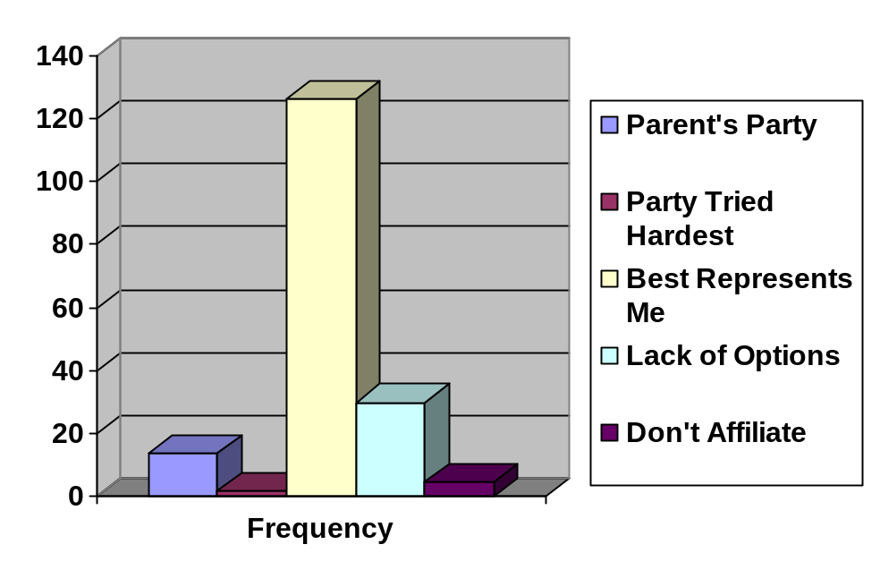

Table 21: Cross-Tabulation of Reason for Party Identification and Party Identification

 |  |  | Party Identification |  |  |  |  | Total
 |  |  | Rep. | Dem. | Ind. | None | No Resp. | Total
Reason for Party Identification | Parent’s Party | Count | 4 | 6 | 3 | 0 | 1 | 14
Reason for Party Identification | Parent’s Party | % within ptyidnes | 10.3% | 6.7% | 11.5% | .0% | 25.0% | 7.9%
Reason for Party Identification | Party Tried Hardest | Count | 0 | 2 | 0 | 0 | 0 | 2
Reason for Party Identification | Party Tried Hardest | % within ptyidnes | .0% | 2.2% | .0% | .0% | .0% | 1.1%
Reason for Party Identification | Best Represents  Me | Count | 34 | 79 | 6 | 7 | 0 | 126
Reason for Party Identification | Best Represents  Me | % within ptyidnes | 87.2% | 87.8% | 23.1% | 38.9% | .0% | 71.2%
Reason for Party Identification | Lack of Options | Count | 1 | 3 | 16 | 10 | 0 | 30
Reason for Party Identification | Lack of Options | % within ptyidnes | 2.6% | 3.3% | 61.5% | 55.6% | .0% | 16.9%
Reason for Party Identification | Don’t Affiliate with a Party | Count | 0 | 0 | 1 | 1 | 3 | 5
Reason for Party Identification | Don’t Affiliate with a Party | % within ptyidnes | .0% | .0% | 3.8% | 5.6% | 75.0% | 2.8%
Total |  | Count | 39 | 90 | 26 | 18 | 4 | 177
 |  | % within ptyidnes | 100.0% | 100.0% | 100.0% | 100.0% | 100.0% | 100.0%

Table 22: Cross-Tabulation of Reason for Party Identification and the 2004 Presidential Election

 |  |  | Vote in the 2004 Presidential Election |  |  |  |  |  |  | Total
 |  |  | Bush | Kerry | Nader | Cobb | Other | No Resp. | No Resp. | Total
Reason for Party Identification | Parent’s Party | Count | 5 | 6 | 0 | 1 | 0 | 2 | 0 | 14
Reason for Party Identification | Parent’s Party | % within pres2004 | 11.6% | 5.1% | .0% | 100.0% | .0% | 18.2% | .0% | 7.9%
Reason for Party Identification | Party Tried Hardest | Count | 0 | 2 | 0 | 0 | 0 | 0 | 0 | 2
Reason for Party Identification | Party Tried Hardest | % within pres2004 | .0% | 1.7% | .0% | .0% | .0% | .0% | .0% | 1.1%
Reason for Party Identification | Best Represents  Me | Count | 30 | 88 | 1 | 0 | 2 | 5 | 0 | 126
Reason for Party Identification | Best Represents  Me | % within pres2004 | 69.8% | 75.2% | 100.0% | .0% | 66.7% | 45.5% | .0% | 71.2%
Reason for Party Identification | Lack of Options | Count | 7 | 18 | 0 | 0 | 1 | 4 | 0 | 30
Reason for Party Identification | Lack of Options | % within pres2004 | 16.3% | 15.4% | .0% | .0% | 33.3% | 36.4% | .0% | 16.9%
Reason for Party Identification | Don’t Affiliate with a Party | Count | 1 | 3 | 0 | 0 | 0 | 0 | 1 | 5
Reason for Party Identification | Don’t Affiliate with a Party | % within pres2004 | 2.3% | 2.6% | .0% | .0% | .0% | .0% | 100.0% | 2.8%
Total |  | Count | 43 | 117 | 1 | 1 | 3 | 11 | 1 | 177
 |  | % within pres2004 | 100.0% | 100.0% | 100.0% | 100.0% | 100.0% | 100.0% | 100.0% | 100.0%

Table 23: Cross-Tabulation of Reason for Party Identification and 2000 Presidential Election

 |  |  | Vote in 2000 Presidential Election |  |  |  |  |  | Total
 |  |  | Bush | Gore | Nader | Other | Did Note Vote | No Resp. | Total
Reason for Party Identification | Parent’s Party | Count | 4 | 3 | 0 | 0 | 6 | 1 | 14
Reason for Party Identification | Parent’s Party | % within pres2000 | 11.1% | 6.4% | .0% | .0% | 9.0% | 7.7% | 7.9%
Reason for Party Identification | Party Tried Hardest | Count | 1 | 0 | 0 | 0 | 1 | 0 | 2
Reason for Party Identification | Party Tried Hardest | % within pres2000 | 2.8% | .0% | .0% | .0% | 1.5% | .0% | 1.1%
Reason for Party Identification | Best Represents  Me | Count | 22 | 38 | 8 | 1 | 49 | 8 | 126
Reason for Party Identification | Best Represents  Me | % within pres2000 | 61.1% | 80.9% | 72.7% | 33.3% | 73.1% | 61.5% | 71.2%
Reason for Party Identification | Lack of Options | Count | 9 | 5 | 2 | 2 | 10 | 2 | 30
Reason for Party Identification | Lack of Options | % within pres2000 | 25.0% | 10.6% | 18.2% | 66.7% | 14.9% | 15.4% | 16.9%
Reason for Party Identification | Don’t Affiliate with a Party | Count | 0 | 1 | 1 | 0 | 1 | 2 | 5
Reason for Party Identification | Don’t Affiliate with a Party | % within pres2000 | .0% | 2.1% | 9.1% | .0% | 1.5% | 15.4% | 2.8%
Total |  | Count | 36 | 47 | 11 | 3 | 67 | 13 | 177
 |  | % within pres2000 | 100.0% | 100.0% | 100.0% | 100.0% | 100.0% | 100.0% | 100.0%

Another interesting aspect of this data is that very few respondents answered that the main reason for their party identification was that it was the same party their parent’s identified with. This suggests that, although voters may vote similarly to their parents, they do so of their own decision based upon their values and beliefs. The dominance of the two-party system may be shown as a factor in this data on party identification because those voters who are not strongly attached to a party are mostly feeling left out of representation and are simply voting that way because of a “lack of options.”

Conclusions

While this article was in particular, an attempt to observe any backlash against third parties due to Nader’s 2000 Presidential campaign, it turned a more important and encompassing inspection of the strength of third parties versus the two-party dominance within our current political system. Although many questions may have been answered through the examination of the survey responses, many more have emerged. It is clearly evident that the two major parties control the electoral process. I have also shown that Nader’s campaign in 2000 did have a backlash against third party voting and support, but mainly among Democrats who were closer to him ideologically than Republicans and who had repeatedly accused him of giving the victory to Bush. I have also shown that most voters see third parties as unviable politically, especially during elections, even when given a chance to pick by preference disregarding the actual vote. They face incredible discrimination within the two-party system with numerous obstacles, both imaginary and real.
However, I have also found reasons for optimism among supporters of a multi-party system. Many voters would support a third party that closely represented their beliefs, even among Democrats and Republicans, who overwhelmingly chose their party identification based upon that same representation of their beliefs. Half of the voters also already see third parties as influential in American politics, although it is impossible to discern how much of that perceived influence is positive and how much is negative.
A number of questions arise from this study. This first is whether voters actually determine their party identification based upon their parents. If they choose their party identification on their own, third parties would be wise to target the young, perhaps even those not old enough to yet vote. Further research would be required in this area, but possibilities may exist for third party success. Another avenue of research could look into the perceived differences in third parties based upon the issues, the candidates, etc. There were indications in the survey that Ventura voters dramatically differed from Nader voters, even when it came to supporting a third party. Perhaps Ventura’s viability to win makes the difference. Legitimization was conferred by Ventura actually achieving electoral success. While solidifying much of the prior research regarding third party voting, my research opens up new questions for political scientists to answer.

Appendix I: Survey Questions

One of each of the following three questions was found on each survey, with “Ralph Nader” on two of the surveys and the other two questions asked on the other two surveys.

After the results of the 2000 presidential election, are you more or less likely to vote for a third-party candidate?
After Ralph Nader’s 2000 presidential campaign, are you more or less likely to vote for a third-party candidate?
After the debacle of the 2000 presidential election, are you more or less likely to vote for a third-party candidate?

The possible responses were:
- much more likely
- somewhat more likely
- somewhat less likely
- much less likely
- no impact on vote

Regardless of how you voted, please rank the candidates in order of preference.
__ Roger Calero – Socialist Workers
__ Michael Peroutka – Constitution
__ George W. Bush – Republican
__ Thomas J. Harens – Christian Freedom
__ Bill Van Auken – Socialist Equality
__ John F. Kerry – Democratic-Farmer-Labor
__ David Cobb – Green
__ Ralph Nader – Better Life
__ Michael Badnarik – Libertarian
*Note: The candidates appeared in the order that they were to appear on Minnesota ballots.

Did Jesse Ventura’s election as governor 6 years ago increase, decrease or have no effect on your likelihood to vote for a third party presidential candidate today?
- Jesse Ventura’s election increased my incentive to vote for a third party presidential candidate today.
- Jesse Ventura’s election decreased my incentive to vote for a third party candidate today.
- Jesse Ventura’s candidacy had not effect on my incentive to vote for a third party presidential candidate today.

If a third party most closely represented your beliefs, would support that party?
- yes
- no

Do you feel third parties are an influential force in politics?
- yes
- no

Which of the following best describes the reason you identify with the party you do?
- It was my parent’s party.
- It is the party that tried the hardest to get my vote.
- It is the party that best represents how I see myself.
- Lack of options
- I don’t affiliate with a party
Exit Survey

The exit poll was a nonrandom sample of a total of 777 individuals. The polling took place in every polling precinct in the city of Morris, a rural farming community of 5,000 in Western Minnesota, one polling precinct in the center of Roseville, a middle-class inner ring suburb of the Twin Cities, and at one polling precinct along Lake Street in Minneapolis, one of the most ethnically and racially diverse areas in the upper Midwest. The sample was not representative of the population as a whole. Gender, education, actual voting outcomes, and age were all skewed in the sample. 58.4% of those surveyed were 18-30 year olds, 15.2% were 31-44, 16.7% were 45-60, and only 5.4% were 61+ years old. In gender, the sample was 42.7% male and 51.4% female. In education, one respondent had only completed grade school, 1% of respondents had some high school, 6.8% had only a high school degree, 50.8% had some college, 19.6% were college graduates, and 16% had graduate or professional school degrees. Voting outcomes are perhaps the most statistically skewed response in the survey with only 24.5% of voters claiming they voted for Bush, 67.7% voted for Kerry, .8% for Nader, 1% for Cobb, 1.4% for other, and .5% who did not vote for a Presidential candidate. Utilizing the NES studies question on party ID, 19.7% of respondents thought of themselves as Republican, 52% as Democrats, 16.7% as Independents, and 8.4% as other. Despite these drastic variations from the national average, or even the Minnesota average, the data is still viable. By completing cross tabs through the various groups, I erased many of the concerns regarding these divergences.

Works Cited

Niemi, Richard G. and Herbert F. Weisberg, ed. Controversies in Voting Behavior. Washington D.C.: Congressional Quarterly, 2001.

Disch, Lisa Jane. The Tyranny of the Two-Party System. New York: Columbian University Press, 2002.

Lentz, Jacob. Electing Jesse Ventura: A Third-Party Success Story. Boulder: Lynne Rienner, 2002.

Herrnson, Paul S. and John C. Green, ed. Multiparty Politics in America. Lanham: Rowman and Littlefield Publishers Inc, 2002.

CNN. (2004, November 19). Election Results. Retrieved November 20, 2004, from http://www.cnn.com/ELECTION/2004/

MulitEducator. (2004, November 4). ElectionsCentral: A History of Presidential Elections. Retrived November 20, 2004, from http://www.multied.com/elections/

Truman Library. (2004, November 21). Election Results 1948-2000. Retrieved November 21, 2004 from http://www.trumanlibrary.org/museum/4years/election1948.htm

