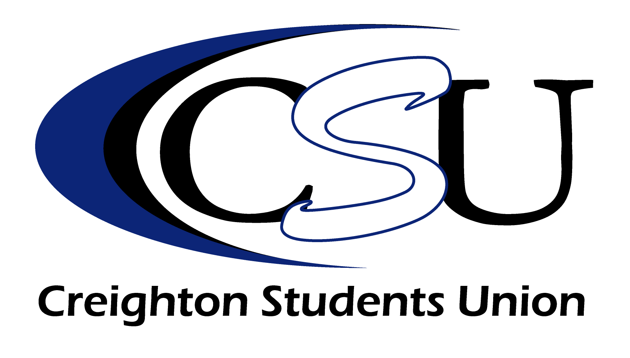

Robert F. Kennedy

Memorial Award for Teaching Achievement

Nomination Form

The 2010 Robert F. Kennedy Memorial Award for Teaching Achievement will be awarded at one of the two May Commencement Ceremonies (depending on the school or college of the recipient). All current full-time faculty members are eligible to receive the award, provided they have had full-time status for a period of no less than two consecutive years preceding the nomination. Nominations for the award may be made by professional, graduate, or undergraduate students.

Name of Nominee:________________________________________________________________________________________________________________________________
Department:______________________________________________________________________________________________________________________________
Your Name:____________________________________________________________________________________________________________________________________________
Address:______________________________________________________________________________________________________________________________________
Phone Number:__________________________________________________________________________________________________________________________
E-mail:_________________________________________________________________________________________________________________________________________
Your College/School and Class:_________________________________________________________________________________________________
The following criteria will be used for selection by the committee. You may add additional support information if warranted.

- Competence of subject area.

- Ability to inspire students and to present subject matter in an interesting and effective manner so as to stimulate maximum learning.

- Considerable interest and concern for students as individuals.

- Service to the students and to the University.

- Cannot be a previous winner of the award.

Please use specific examples to substantiate how your nomination embodies the above qualities. We recommend you use a separate sheet of paper to write on the first four criteria above and that you not exceed 2 typed pages. Thanks!

Return this form to the Student Activities Office, or mail to:
Robert F. Kennedy Memorial Award
Creighton Students Union – Skutt Student Center 110
Creighton University
2500 California Plaza
Omaha, Nebraska 68178

*Nomination forms must be completed and returned by 4:30 PM on March 26th*

Questions? Please contact Matthew Gillespie at cscos@creighton.edu
Robert F. Kennedy Memorial Award

for Teaching Achievement

List of Past Recipients

- Dr. Richard D. Shugrue, School of Arts and Sciences
- Dr. Francis M. Klein, College of Arts and Sciences
1973 Dr. Frank M. Ferraro, School of Medicine
- Sheila A. Ryan, School of Nursing
- Dr. Orville H. Zabel, College of Arts and Sciences
- Richard Sieling, College of Arts and Sciences
- William R. Heaston, College of Business Administration
- Dr. Raymond W. Shaddy, School of Dentistry
- Fr. James L. Datko, College of Arts and Sciences
- Fr. Leonard A. Waters, S.J., College of Arts and Sciences
- Dr. Loy L. Julius, School of Dentistry
- Roland J. Santoni, School of Law
- Bette Novit-Evans, College of Arts and Sciences
- Dr. William A. Albano, School of Medicine
- Dr. James S. Wunsch, College of Arts and Sciences
- Dr. Joseph M. Phillips, College of Business Administration
- Dr. Walter A Brzeninski, School of Medicine
- Sr. Maryanne Stevens, Faculty
- Andrew K. Hoh, College of Business Administration
- Nancy W. Perry, College of Arts and Sciences
- Ronald J. Hospodka, School of Pharmacy
- Dr. Ashton Welch, College of Arts and Sciences
- Dr. Edward O’Connor, College of Arts and Sciences
- Dr. Robert R. Johnson, College of Business Administration
- Dr. Martin Hulce, College of Arts and Sciences
- Dr. Robert S. Dornsife, College of Arts and Sciences
- Ms. Ginger Parker, College of Business Administration
- Dr. Gregory Zacharias, College of Arts and Sciences
- Dr. Brian S. Hook, College of Arts and Sciences
- Dr. Anthony E. Kincaid, School of Pharmacy
- R. Collin Mangrum, S.J.D., School of Law
- Dr. Tom Lewis, College of Business Administration
- Dr. Neil S. Norton, School of Dentistry
- Dr. Terry Clark, College of Arts and Sciences
2005 Professor Ronald Volkmer, J.D., School of Law
2006 Dr. Jeffrey Hause, College of Arts and Sciences
2007 Dr. John Wingender, College of Business Administration
2008 Dr. Gary Michels, College of Arts and Sciences
2009 Dr. Thomas Kelly, College of Arts and Sciences
2010 Dr. Victoria Roche, School of Pharmacy

