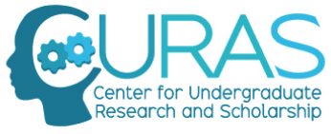
CURAS Student Ambassador Program
2020-2021 Application

CURAS Student Ambassadors are leaders in undergraduate research who support and enhance the work of CURAS by building a culture of undergraduate research on campus. Student Ambassadors will be chosen to serve for the 2020-2021 academic year. Undergraduate student applicants must be actively involved in a research project for at least a semester before applying to be a CURAS Ambassador. CURAS is looking for undergraduate research students from all disciplines, but is especially interested in applicants from business, the humanities, and the social sciences.

Requirements of CURAS Student Ambassadors: If I am selected as a CURAS Ambassador, I agree to the following conditions:

- Attend monthly all-Ambassador meetings to discuss CURAS business and share research

- Commit 10-15 hours/semester to Ambassador activities. These include but are not limited to:
  - peer-mentoring
  - staffing CURAS events
  - staffing admissions events (Special Programs Day, Admitted Student Days, tours/presentations to high school students interested in research opportunities at Creighton)
  - staffing Summer Previews
  - participating in panel discussions or presenting in classes about undergraduate research
  - engaging others in outreach
  - hosting All-University Research Fair and Research Day

- Attend CURAS-sponsored events

- Present research project results at University Research/St. Albert’s Day

- Maintain a minimum GPA of 3.0.

Benefits for Ambassadors

- $250 annual stipend to each student to cover research-related expenses (conference travel, supplies needed for project, etc.)

- Leadership development and peer-networking

- First access to any research-related programming sponsored by CURAS

- CURAS Student Ambassador polo

- Opportunity to apply to serve on the CURAS Leadership Board

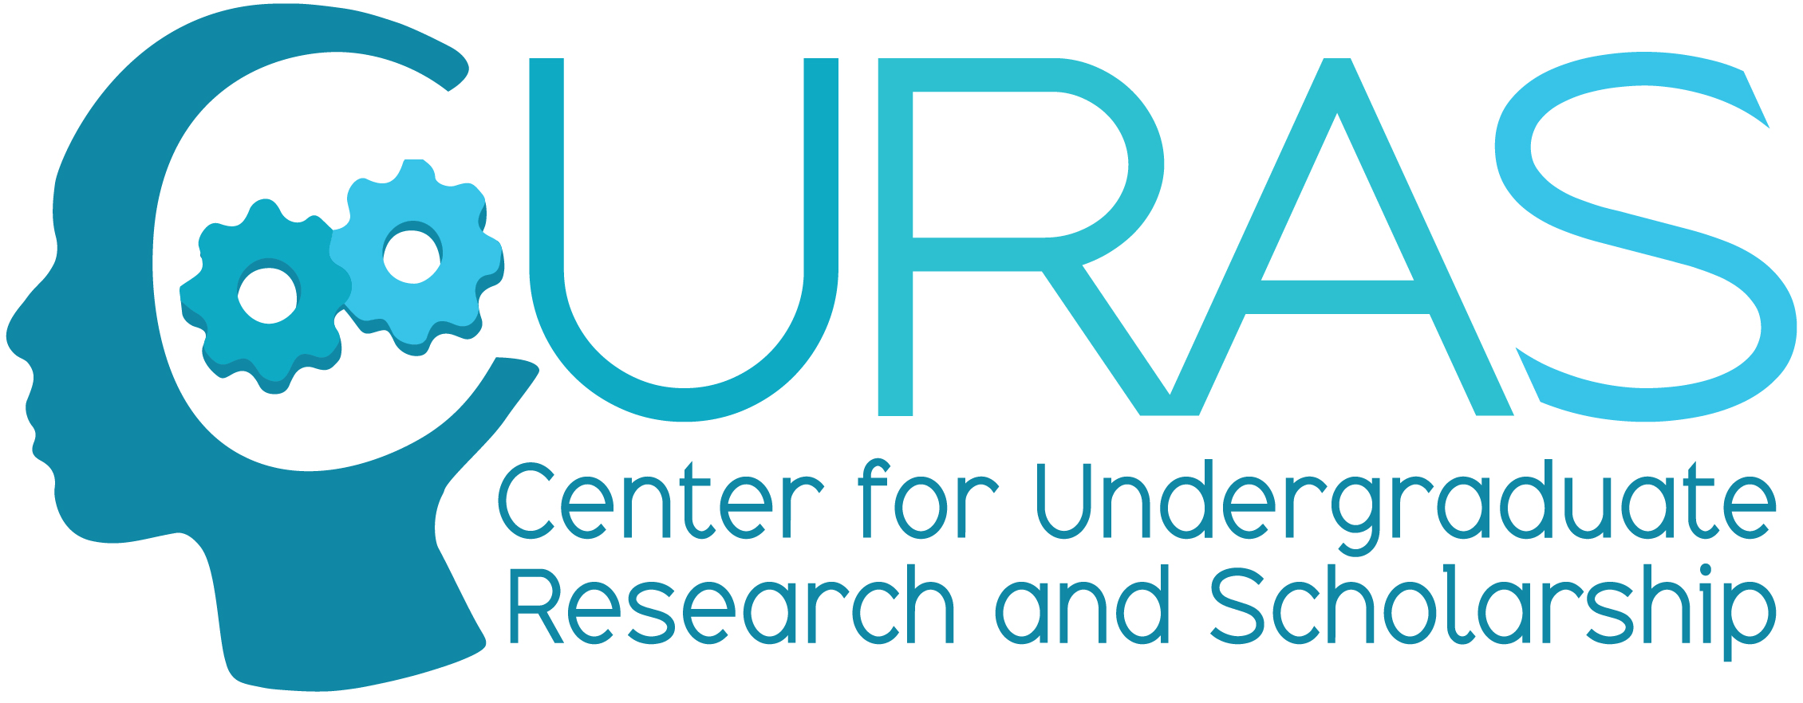
CURAS Student Ambassador Program
2020-2021 Application

Applicant Information: Responses may be typed, but your signature should be handwritten.

NAME: ________________________________________________ EMAIL: ___________________________________

MAJOR(S): _____________________________________________ STUDENT ID: _____________________________

EXPECTED GRADUATION DATE: _________________

LOCAL ADDRESS: ________________________________ PERM. ADDRESS: _______________________________
________________________________ _______________________________
________________________________ _______________________________
LOCAL PHONE: _________________________________ PERM. PHONE: _______________________________

SIGNATURE (Digital okay): ____________________________ DATE: __________________________

The 2020-2021 CURAS Student Ambassador application has three steps.

Application Step One:

Complete the above Applicant Information section.

Application Step Two:

Please answer the following three questions. You may choose between submitting your responses as a typed personal statement OR as a short video.

- What research experience(s) (please specify your research mentor) and involvement with CURAS have you had up to this point?
- Why would you like to become a CURAS Ambassador?
- What talents and skills will you bring to the CURAS Ambassadors Program?

typed personal statement: no more than 2 pages, double-spaced
short video: no more than 3 minutes; note that videos are evaluated on the basis of content only--no fancy production skills needed!

Application Step Three:

Include in your application a copy of your resume or curriculum vitae (CV). Be sure to list your current and past leadership experiences.

PLEASE SUBMIT YOUR APPLICANT INFORMATION, PERSONAL STATEMENT, AND RESUME/CV TO:
curas@creighton.edu

TO SUBMIT YOUR VIDEO:
Please email MeghanFreeman@creighton.edu; she will invite you to submit your video via JayDrop.

All 2020-2021 CURAS Student Ambassador Applications are due:

May 1, 2020 at 4:00 pm

