Published in ADA News
August 15, 2011

Creighton connects with Native American students through summer enrichment program
By Karen Fox, ADA News staff
Omaha, Neb.—Creighton University School of Dentistry completed its third Native American Summer Enrichment Program last month, capping off a grant period that drew 16 American Indian college students to the dental school for a comprehensive look at what dental school entails and what they have to do to achieve that goal.
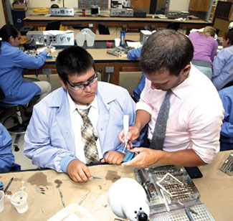
Mentoring: Matthew Wilson (left) of Mission, S.D., a member of the Rosebud Sioux, simulates endodontic therapy on models with senior dental student mentor Luke Sharpe at Creighton University this summer. Photos by Ford Jacobsen
School officials believe they’ve latched on to a winning formula with the four-week program. They’ve seen the number of applicants rise every year since the program began: 27 sought entry this year, compared to 20 in 2010 and four in 2009.
“We know there is interest in this type of dental school preparation for Native American students and that students are more likely to continue in their educational path for dentistry with the help of this program,” said Kelly Gould, assistant professor of community and preventive dentistry and director of extramural programs at Creighton.
It’s begun to show results, too. One student in the first summer enrichment program is now a second-year dental student at Creighton. Another is in the school’s predental post-baccalaureate program—he’s on track to be a first-year dental student in 2012. Students from the second cohort are applying to dental school, and the third cohort have indicated a strong interest in dentistry. In fact, one has worked as a dental assistant.
Creighton prefers to limit participation to students with some college experience, but word of mouth has created demand. High schools are calling to find out how they can send students to future events.
“The students we accept have likely already made some choices that have allowed them be accepted to college or even have a track record of being college students,” said Ms. Gould, a dental hygienist. “If we were able to, we would offer a program for younger ages because we would have enough people to fill it.”
The way the summer enrichment program has been funded is the main reason for its success. Funding has enabled the program to have a wide reach among universities with a critical mass of Native American students and tribal colleges, as well as make it worth the students’ time to attend.
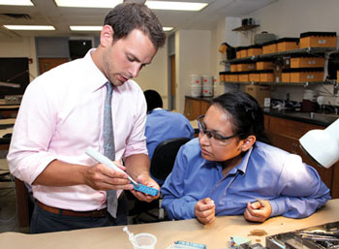
Time to teach: Luke Sharpe, senior dental student mentor, demonstrates a technique for Brittany Ironmaker of St. Ignatius, Mont., a member of the Sisseton Wahpeton tribe who has worked as a dental assistant.
It began with a three-year grant from the Robert Wood Johnson Foundation that focused on the recruitment of more Native American students in the dental profession. Creighton was funded in the second round of the RWJF Dental Pipeline program (2001-10), which among other things, sought to increase the minority and low-income student enrollment in dental schools. Three universities in the Jesuit university network—Creighton, Marquette and Gonzaga—collaborate on programs that identify promising Native American undergraduates with an interest in health careers and strong tribal affiliations. The universities send those students to Creighton’s summer enrichment program and encourage the ones who need more preparation for dental school to apply for the school’s predental post-baccalaureate program.
Tribal affiliations are key to acceptance for both summer enrichment and the predental post-baccalaureate program.
“There are 4.5 million Native Americans in the U.S. but only 150 Native American dentists,” said Dr. Gary H. Westerman, chair and professor, department of community and preventive dentistry, who has taught the summer enrichment students all three years. “That’s obviously a shortage, so if we can identify students that have a positive affiliation with their tribes, they may return to their reservations to practice dentistry.”
“All applicants write a personal statement about how this might benefit them and explain their connection to their tribes and cultures,” added Ms. Gould. “You can see quickly whether they have cultural ties. Many say their dream is to become a dentist and serve the people in their communities because there aren’t enough dentists there.”
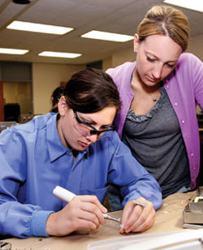
Attention to detail: Cristin Haase (left) of Lidgerwood, N.D., a member of the Cheyenne River Sioux, performs endodontic therapy under the watchful eye of dental student Tracy Wells.
With additional funding provided by Creighton University, the summer enrichment program presents students with a $1,000 stipend once they complete the program. Ms. Gould explained the value of the stipend: “We didn’t provide it at first, but we received feedback from some applicants saying they would like to have applied but had a summer job and needed money for college. The stipend gave them a strong incentive to come and further their education and not lose out on that earning potential.”
Housing, meals and all program costs are covered as well.
From June 20-July 15, undergraduate students learned about dental careers; participated in clinics, labs and classes; prepared for admission to dental school; and learned about financial aid. “There was a good overview of disciplines taught, including restorative dentistry, surgery and pediatrics, and exposure to basic sciences, histology and gross anatomy, along with hands-on laboratory activities,” said Dr. Westerman. Fourth-year dental students plan lab activities and serve as mentors for the undergraduates.
Summer enrichment faces an uncertain future at the conclusion of the three-year grant, but officials say they will continue to look for ways to help sustain the program.
“We are looking forward to the day when Native American dental students can be mentors for summer enrichment students, too,” said Ms. Gould.

