REGISTER AS AN IRBNet USER

If you have never registered go to [IRBNet](https://www.irbnet.org/release/index.html) and register as a new user. Once you register you will receive an email which directs you back to IRBNet, open your user profile and this will activate your account.

CAUTION: If you have forgotten your user name DO NOT re-register, call 402-280-2126 and have an IRB administrator access your user account. If you forgot your Password clink on “Forgot Your Password”, your password will be sent to your email. The IRB administrators strongly suggest that you use your employee user name and password. You may change your password at any time, once entered you may never change your use name.

As an investigator or study team member experienced with or new to IRBNet, you will want to ensure your training and credentials are up to date in your User Profile, and filed with your local committee as required by their SOPs. The following steps walk you through how to manage your User Profile and meet the project credential requirements of your committee.

A. Upload and Submit Your Training & Credentials from your User Profile (page 1 and 2)

B. Link Project Team Credentials into a Project Package (page 3)

C. Keep Your Training & Credentials Current (page 4)

D: Trouble Shooting (page 5)

**A. Upload and Submit Your Training & Credentials from your User Profile**

* Log into IRBNet and click the User Profile link in the top right corner of the screen.
* In the External Accounts section (middle of the page) click the Add an External Account button. You must add your CITI membership Number, This number can be found at the top of your CITI homepage upon login.



* The system will send you an email and you are to follow the instructions in the email to verify your CITI training. [the email will instruct you to click on the link, which takes you to the IRBNet home page, login; and open your user profile] this will verify your CITI member number. After verification the CITI training will automatically be downloaded into your account. The download may take up to 24 hours.

* In the Training & Credentials section (bottom of the page) click the Add New Record button.

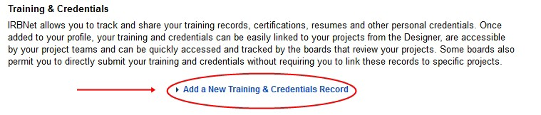

* On the Training & Credential Record page, select the appropriate training and credential Document Type, enter the Effective Date of the document (ex. NIH Training, CV or professional license) and any other applicable information, and then select the file from your computer by clicking the Browse button. [NOTE: do **NOT** upload CITI training certifications; this is automatic with the external link]
* Once the correct file is selected, click ‘Attach’.
* From the User Profile page, click the “Submit” link (to the right of the new document listing you have just created).

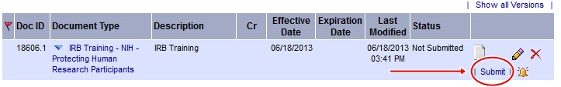

* Select the organization to which you will be submitting your documentation.
* Type a message to your committee’s administrator and click the Submit button.
* Repeat steps 3-8 for any other documentation you are required to submit based on your local committee SOPs.
* If you need to ‘update’ a record, click the ‘pencil’ icon to the right, and follow instructions.

In addition to directly submitting documentation to your committee, you may be asked to provide training documentation during the protocol submission process. Having followed the previous steps, you may link any existing training documentation to a project package by following the steps below.

**B. Link Project Team Credentials into a Project Package**

Once the project has been created, ensure all the members of the research team have been shared access to the project within IRBNet (see R1 Energizer for a detailed walk- though of this process).

Click the Designer button to the left.

Below the list of documents in the package, click the “Link / Un-Link Records” link.

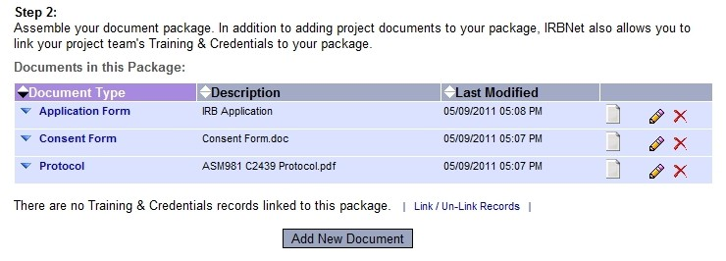

* On the list of available documents, check the box next to those that should be linked to this package and click Save.

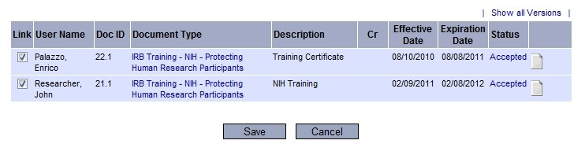

*Note*: If required documentation is missing, make sure the researcher in question has access to the project and has followed the steps outlined in the first section.

* Having linked all necessary training documentation, complete the process of submitting this package to the appropriate committee.

On a continuing basis you will need to keep your Training & Credentials documentation up to date within your User Profile. When you have an updated version of an existing document, or need to make changes for any reason, you should walk through the following process to ensure this updated information is available to the appropriate committee.

**C. Keep Your Training & Credentials Current**

* Access your User Profile
* Please note that if your have linked your CITI account to IRBNet all future training will be downloaded (this may take up to 24 hours)
* Locate the appropriate document and click the Pencil icon.

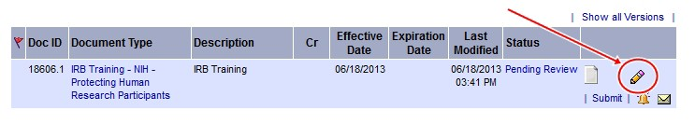

* Edit the Training & Credentials Record page as needed, click the Browse button to locate the updated version of the document.
* Click the Update button.
* Having attached the updated document, you now need to submit it to the appropriate committee. Click the Submit link and select the appropriate committee to submit to.

**Troubleshooting**

If you are unable to verify your CITI account, please make sure of the following:

1. You have entered the correct CITI Member ID

2. Your CITI account is active (if not call the CU Education Coordinator at 402-280-2680)

*DO NOT SET UP A SECOND CITI ACCOUNT” the education coordinator can access your user name.

3. Your CITI institutional email address is correct

To access the institutional email address associated with your CITI affiliation

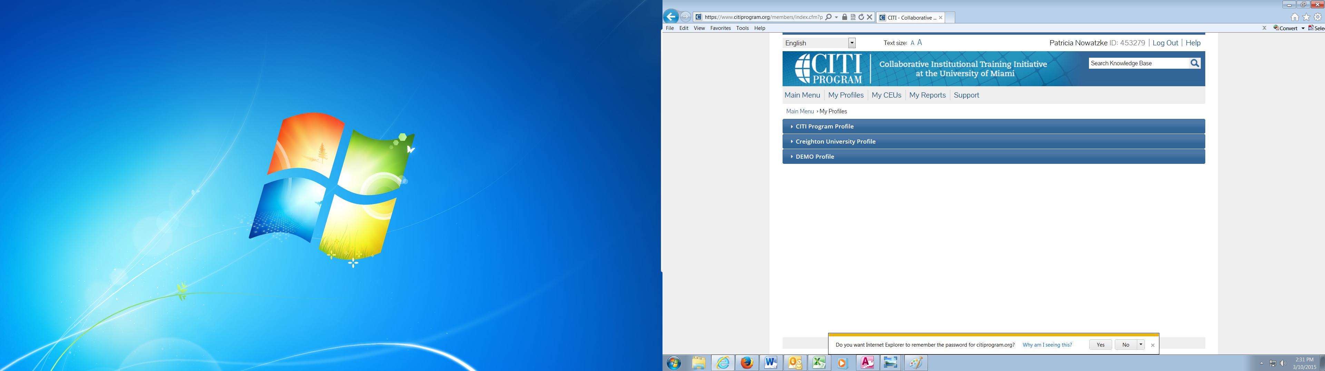

Click on “My Profile”

Then Click on Creighton University Profile, check email and update if necessary.