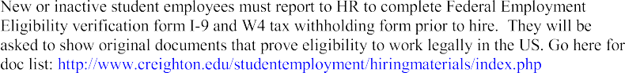
--IMPORTANT--

Employment Authorization

TO BE USED FOR CREIGHTON UNIVERSITY STUDENTSONLY

DEPT. NAME DEPT. #

FUND # * ORGANIZATION # ACCOUNT #

CHECK PAYMENT METHOD:
*CONTROLLER’S OFFICE

Supervisors are required to obtain cosignature from the Controller on any hiring done under 200000 series funds. Print completed PR2S and forward to Controller.

HOURLY MONTHLY*

*IF MONTHLY, TOTAL
NUMBER OF PYMTS:

SEO COMMENTS | LAST, FIRST, MI | NET ID | INDICATE ACTIONS:  - ENGAGE,  - DISENGAGE  - PAY RATE ADJ  - FUNDING CHANGE | $$ PAY RATE | STAFF MEMBER WHO WILL APPROVE TIMECARD : | EFFECTIVE DATE

HIRED BY (PRINT NAME):

Comments: Comments: Comments: Comments:

DATE (MM/DD/YYYY):

phone : email: @CU

Processed by Student Employment staff: DATE:

