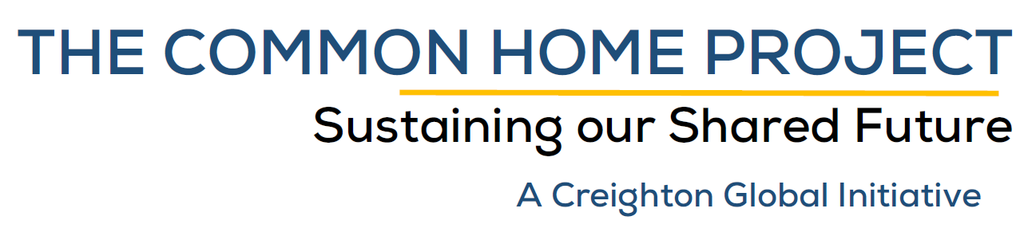
The grant application process in the Common Home Project is unique – it is accomplished through a collaboration between the applicant(s), Creighton University’s Global Engagement Office, and a Common Home Project hub partner. You may apply at any time, and your application form does not need to be complete in order for you to initiate the project consultation. Projects will be considered only for the seven partner “hubs” listed below. You need not have identified the partner to apply – the Global Engagement Office will assist in locating a partner that has interest in collaborating with Creighton University on this project.

Please contact René Padilla, PhD, vice provost for Global Engagement, with any questions at (402) 280-4745 or RenePadilla@creighton.edu.

Please follow this template and do not modify it throughout the application process. The template matches the United Nations’ Higher Education Sustainability Initiative reporting structure. The CHP is committed to report all its projects through HESI in order for the results to be included in each country’s Sustainable Development Progress Report.

1. Type of Application
 | Please identify the type of application you are submitting
 | Preliminary | This is an exploratory application. You must complete the items marked with an asterisk (*) and as many other items as you like.
 | Complete | This is a final application, ready to be submitted to the review committee for final decision. All items must be complete.

- Partner(s)/ Location(s)*
Note: If you need assistance identifying a partner in one of our Common Home Project Hubs, please indicate this below. Although it is not essential to have identified a partner in the initial application, it will be in determining if the project is funded. Once you submit this proposal, the Global Engagement Office will contact you to set up a meeting to discuss a partner exploration plan.
 | Country | Common Home Project Partner Hub
 | U.S.A. | Creighton University – Omaha
 | Dominican Republic | Centro de Educación para la Salud Integral (CESI) - Santiago  Pontificia Universidad Católica Madre y Maestra (PUCMM) - Santiago
 | Ecuador | Pontificia Universidad Católica del Ecuador (PUCE) - Quito
 | Uganda | Uganda Martyrs University - Nkozi / Masaka / Kampala / Rugaba
 | India | St. Xavier ’s College, Autonomous - Mumbai  St. Joseph’s College, Autonomous - Bangalore
 | Philippines | Ateneo Manila University - Quezon City
 | Undetermined | Am not sure - Would like to explore the best match.

- Contact Information*
Creighton University Contact: | First Name: |  | Last Name:
 | Title:
 | E-mail:
 | Telephone:
Partner University Contact:  (if known) | First Name: |  | Last Name:
 | Title:
 | E-mail:
 | Telephone:

- Sustainable Development Goals (SDGs)*
Consult the “Global Indicator Framework for the Sustainable Development Goals and Targets of the 2030 Agenda for Sustainable Development” and complete the following 3 steps:
- In column A below indicate the number of the PRIMARY SDG your project contributes to;
- In column B indicate the SDG target(s) that best correspond to your project; and
- In column C indicate the indicator(s) that best correspond to your project.

If you need assistance identifying targets and indicators that correspond to your project, please contact René Padilla (RenePadilla@creighton.edu)
Example: | For the Project: “Provision of Running Water in Rural Dominican Republic Villages.”  Goal 6 (Ensure availability and sustainable management of water and sanitation for all)  Target: 6.1 (By 2030 achieve universal and equitable access to safe and affordable drinking water for all)  Indicator: 6.1.1 (Proportion of population using safely managed drinking water services)
Your Project:
Goal* | Target(s) | Indicator(s)

- Project description (max 100 words)*
Please describe as clearly as possible what the objective of this initiative/partnership/commitment is.

- Coordination mechanisms (max 400 words)
Please clearly describe how this initiative will be governed / coordinated.

- Implementation methodologies (max 400 words)*
Please clearly describe how this initiative will be carried out

- Arrangements for Capacity Building and Technology Transfer (max 400 words)
Please clearly describe how you will make sure individuals and/or organizations will obtain, improve, and/or retain the skills, knowledge, tools, equipment and other resources needed for sustainability of this project after the grant period is over

- Project dates
Start date: | Month: |  | Year:
Date of completion: | Month: |  | Year:

- Deliverables*
Please add at least one, and up to four, tangible deliverable(s), including the final deliverable
(1) |  | Month: |  | Year:
(2) |  | Month: |  | Year:
(3) |  | Month: |  | Year:
(4) |  | Month: |  | Year:
(Final) |  | Month: |  | Year:

- Tentative Budget
Note: The Common Home Project does not cover project leader stipends. Stipends will be considered only in cases when the project clearly requires added (temporary) personnel for execution and no alternative is feasible. Per Diem cost will be covered only during travel and according to Creighton University’s published rates at https://www.creighton.edu/finance/sharedservices/accountspayable/expensereimbursement/mileageandperdiemrates/perdiem/
Travel: | Rationale (include explanation below) | Amount: | $
Per Diem: | Rationale (include explanation below) | Amount: | $
Consultant: | Rationale (include explanation below) | Amount: | $
Supplies: | Rationale (include explanation below) | Amount: | $
Other Expenses: | Rationale (include explanation below) | Amount: | $
 |  | TOTAL: | $

- Comments:
Any comments for the review committee?

- Attestations*
Please check each box to indicate you understand the requirements of the Common Home Project grant program
Attestations
- I understand that the grant requires a collaborative process with GEO to finalize the actual program;
- I understand that the grant must be carried out through a collaborative process with individuals at one or more of the Common Home Project hubs across the globe;
- I understand that before final approval is granted, GEO will request endorsement from your department chairperson and School / College dean.
- I understand that if the grant is approved, I also will be required to plan for a subsequent external grant in collaboration with a partner at a Common Home Project hub and that GEO will provide support via a grant writer who will meet with your team to identify potential grants and assist in writing the future grant application.
- I understand the funding provided for a Common Home Project grant will be administered by GEO, may only be used for pre-approved costs, and unused funding must be returned to the Common Home Project to be used in other grants.
- I have attached my detailed resumé and give GEO permission to submit it to the Common Home Project partner institutions as part of the approval process.

Please sign electronically on the line below:

Please save this application form to your hard drive and send as an MSWord attachment to RenePadilla@creighton.edu.

