Submitting a Form for Strategic Sourcing

Go to myit.creighton.edu

IT will bring up the screen below after you log on with your NETID@creighton.edu

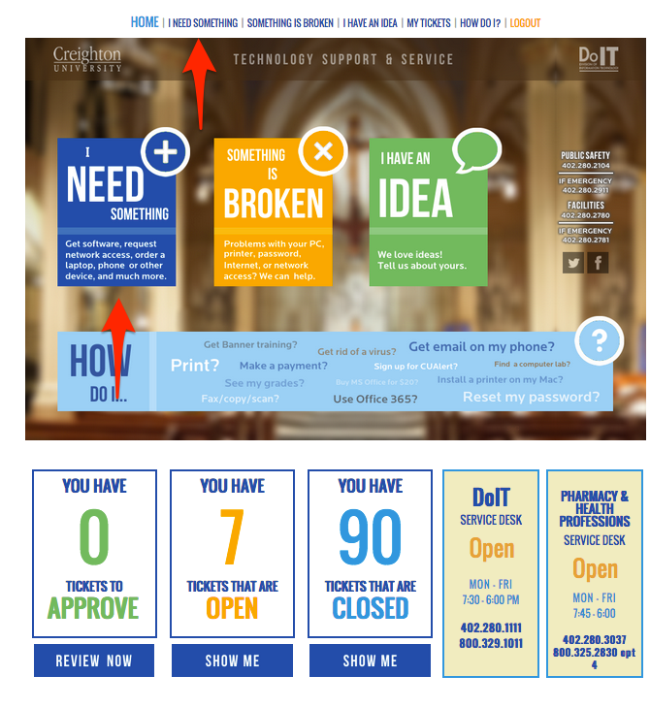

Click on the I Need Something on the top Banner or on the I Need Something Box

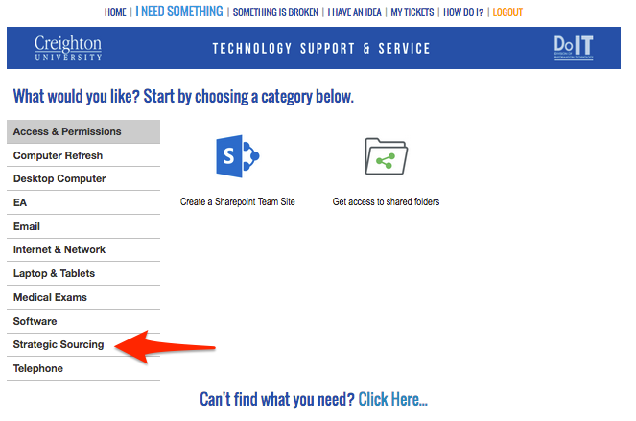
Then you will click on Strategic Sourcing and it will bring up their options
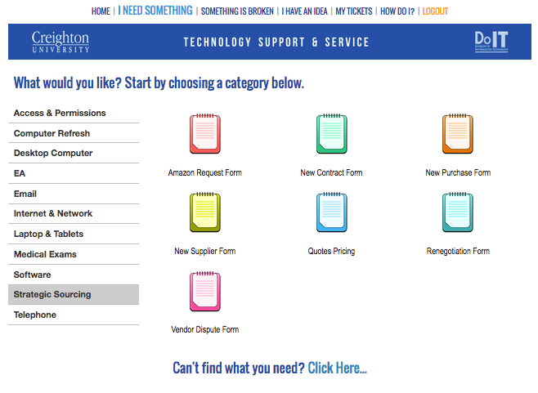

On this screen you will select one of the form you are wanting to submit.

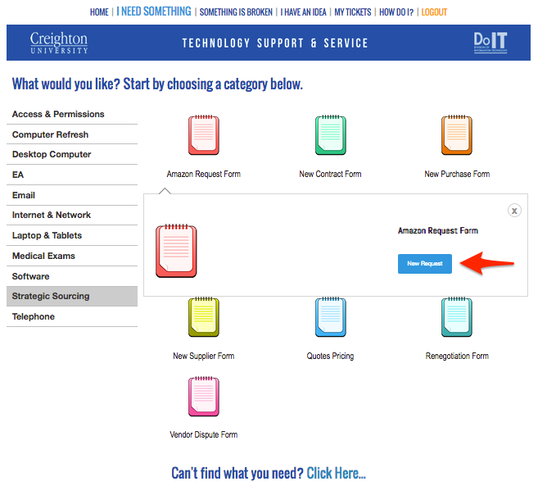

Select the New Request Box

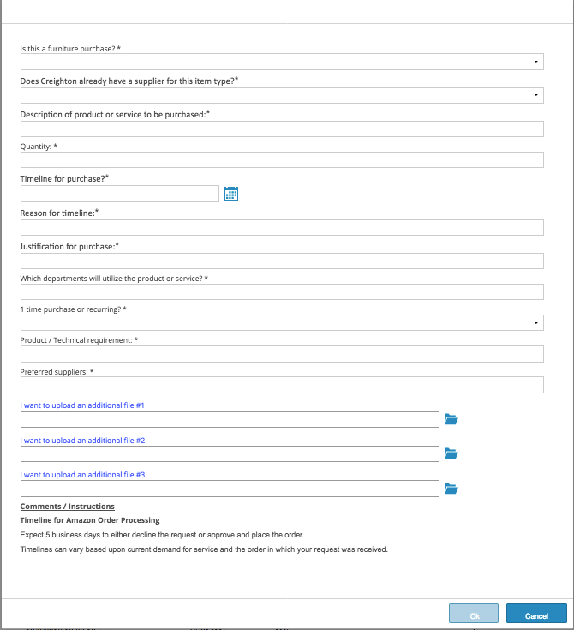

Fill out the Form and then select OK and it will send it over to Strategic Sourcing.

