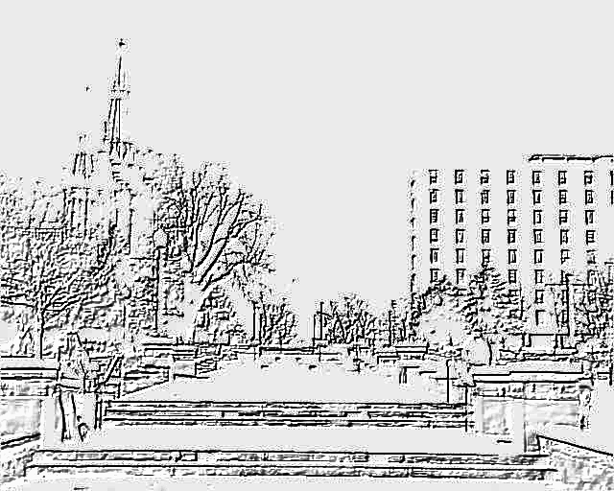

2nd ANNUAL

Honors
Program

Research Presentations

Skutt Student Center
April 12, 2005
3:00 p.m. to 5:00 p.m.


Funding in part provided by the CUR Undergraduate Studies
The
Second Annual
Honors Program
Presentations
Skutt Student Center  April 12, 2005  3:00to 6:00

Research Presentation Schedule

Presenter |  | Time | Section
Kali E. Forbes | Oral | 3:15 – 3:30 p.m. | 1
Mark T. Rusch | Oral | 3:15 - 3:30 p.m. | 2
Mary A. Adams | Oral | 3:15 - 3:30 p.m. | 3
Colleen Hartsig* | Oral | 3:15 - 3:30 p.m. | 4
Carolyn M. Green | Oral | 3:45 - 4:00 p.m. | 1
Mary T. Johnson | Oral | 3:45 - 4:00 p.m. | 2
Laura M. Zapapas | Oral | 3:45 - 4:00 p.m. | 3
Justyna A. Dobrowolska | Oral | 3:45 - 4:00 p.m. | 4
Adam J. Schumacher | Oral | 4:15 - 4:30 p.m. | 1
Jennifer M. Larson | Oral | 4:15 - 4:30 p.m. | 2
Lindsey R. Goetz | Oral | 4:15 - 4:30 p.m. | 3
Christopher W. Cook | Oral | 4:15 - 4:30 p.m. | 4
Jackie K. Lee | Oral | 4:45 - 5:00 p.m. | 1
Tamika L. Butler | Oral | 4:45 - 5:00 p.m. | 2
Kelsey Tinkum | Oral | 4:45 - 5:00 p.m. | 3
Kashmir K. Singh | Poster | 3:15 - 4:15 p.m. | 5
Jariel A. Rendell | Poster | 3:15 - 4:15 p.m. | 5
Brittany Travers | Poster | 3:30 - 4:30 p.m. | 5
Rebecca A. Donahue | Poster | 3:30 - 4:30 p.m. | 5
Ann Kemper | Poster | 4:00 - 5:00 p.m. | 5
Erin Wallace  * Clare Boothe Luce Scholar Presenter | WEB | Fall 2006 | TBA

College of Arts and Sciences
Honors Program Research Presentations

Wednesday, April 12, 2006, 3:00 – 5:00 P.M.
Skutt Student Center Ballroom
Second Annual Honors Presentation Day


Table of Contents

Opening Ceremony
Dean Austin’s Welcome 1

Program Administration
Directors 5
Faculty Advisors 6
Student President 6

Honors Program
Introduction 7
Curriculum Overview 8
Requirements 9

Research Presentation Abstracts
Alphabetical order by Presenter’s Last Name 9

Photo Album 19

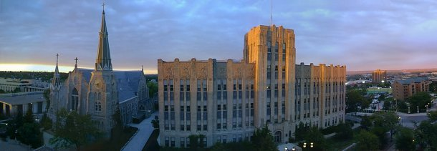

A MESSAGE TO OUR HONORS MEMBERS

Timothy Austin, Ph.D.,
Dean of the College of Arts and Sciences

Those of us who work in universities every day, whether as faculty members or as administrators, know from experience that independent undergraduate research is the hot topic these days. Conferences are dedicated to discussing how to facilitate it. Articles in the Chronicle of Higher Education report on the latest nuances. And schools all across the country proclaim loudly in their recruitment materials that their students have “special opportunities,” or “enhanced opportunities,” or (worst of all) “unique opportunities” to work closely with faculty mentors in pursuing individually designed scholarly or creative projects.

At Creighton, we do more than pay lip service to this important facet of undergraduate education. This booklet and the Honors Day events to which it serves as a guide highlight vividly the reality that lies behind our claim that we too value and promote student research. Behind the abstracts that fill the following pages lie hours of dedicated work in studios, in laboratories, in the library and out in field. Out of these same abstracts, as we know well from past experience, will come presentations at national meetings and co-authored papers in respected refereed journals.

The students in Creighton’s Honors Program rise to every challenge that our faculty place in front of them. Through their hard work, they lend credibility to our assertion that we are training young women and men to think independently and to communicate the results of their studies with legitimate authority. I know that you will be impressed with all that this year’s Honors students have achieved.

I congratulate the Honors students in the graduating Class of 2006.

CREIGHTON UNIVERSITY COLLEGE OF ARTS AND SCIENCES HONORS PROGRAM

Program Administration
The Honors Program is under the supervision of the Dean of the College of Arts and Sciences, administered by the Director and the Assistant Director, who are advised by an Executive Advisory Board, composed of faculty appointed by the Dean. The Student Honors Board serves as a liaison between program administrators and students and also plans activities for the honors program community. The newly established Advising Resource Center (ARC) located in the Hixson-Lied Science Building room G06, in addition to assisting the Director and Assistant Director of the Honors Program, provides resource information for Honors Students and Pre-Health Students about post-baccalaureate scholarships and medical school applications.

Dr. Timothy R. Austin, Dean
College of Arts & Sciences
office: Administration Building
phone: ext. 2431
email: traustin@creighton.edu



Dr. Geoffrey Bakewell, Director
Department of Classical & Near Eastern Studies
office: Humanities Center 209
phone: ext. 5526
email: gbakewe@creighton.edu
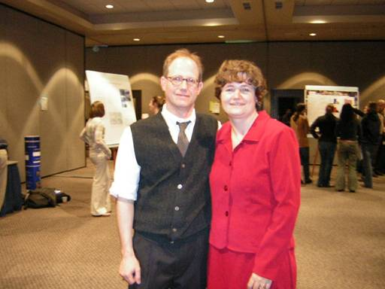
Dr. Isabelle Cherney, Assistant Director
Department of Psychology
office: Hixson-Lied Science Building 308
phone: ext. 1228
email: cherneyi@creighton.edu

Picture taken of Dr. Bakewell and Dr. Cherney at the 2005 Presentation Day
Honors Faculty Advisory Board
Dr. Michael Brown  Department of Philosophy  office: Humanities 111  phone: ext. 2645  email: mbr@creighton.edu | Dr. Terry D. Clark  Department of Political Science  office: Admin 426A  phone: ext. 4712  email: tclark@creighton.edu
Dusten Crichton  Swanson Hall Director-Residence Life  office 119 Swanson  phone ext: 3196  email: dusten@creighton.edu | Dr. Joan M. Eckerson  Exercise Science & Athletic Training  office: Kiewit Fitness Center 227  phone: ext. 2090  email: eckerson@creighton.edu
Fr. J. William Harmless, S.J.  Department of Theology  office: Humanities 132  phone: ext. 2572  email: wharmless@creighton.edu | Dr. Jeffrey P. Hause  Department of Philosophy  office: Humanities 130  phone: ext. 3581  email: jphause@creighton.edu
Dr. Martin R. Hulce  Department of Chemistry  office: Rigge Science 226  phone: ext. 2271  email: mhulce@creighton.edu | Dr. Harry Nickla  Department of Biology  office: Hixson-Lied 424  phone: ext. 2157  email: hnickla@creighton.edu
Dr. Russell R. Reno  Department of Theology  office: HC136  phone: ext. 2929  email: rrreno@creighton.edu | Dr. Janet E. Seger  Department of Physics  office: Hixson-Lied G76  phone: ext. 4709  email: jseger@creighton.edu

The Student Honors Board

Composed of students elected by fellow honors students.

The 2005 - 2006 president is Brittany Travers.
Newly elected 2006 - 2007 president is _____________________

CREIGHTON UNIVERSITY COLLEGE OF ARTS AND SCIENCES HONORS PROGRAM
Rooted in the university’s Christian, Catholic, and Jesuit traditions, the new Honors Program relies on the belief, articulated by Pope John Paul II, that “the united endeavor of intelligence and faith will enable people to come to the full measure of their humanity.” Its goal is to foster a community committed to the ongoing education of students and faculty members as fellow seekers for truth. The program seeks individuals of all faiths and backgrounds who are intelligent, well prepared academically, highly motivated, and academically adventurous. The curriculum then immerses these students in an academically rigorous but flexible program of study guided by a faculty mentor who is charged with paying special attention to the personal dimension of learning. The program ultimately understands itself as a fellowship of inquiry whose individual members have dedicated themselves without reserve to love of learning.
The Program is designed for talented, imaginative students desirous of participation in small, discussion-oriented classes and in courses on interdisciplinary and topical issues. It provides students with special opportunities and challenges to enhance their undergraduate experience and to contribute to the intellectual and cultural life of the University. The Program also offers eligible students the opportunity to pursue a course of study that complements their majors.
Criteria for admission to the Program include academic achievement and demonstrable interest in the Program’s aims and aspirations. Required application materials include a piece of graded writing and an essay.

CURRICULUM OVERVIEW
The new curriculum involves the following key elements:

Foundational Sequence. Honors students take three courses (9 credits) in their first three semesters that introduce them to the Christian, Catholic, and Jesuit intellectual traditions that lie at the heart of a Creighton education within the context of Western civilization and of the pluralistic world we inhabit.

Sources and Methods Courses. Honors students take five courses (15-20 credits) that induce them to think critically about information, assumptions, and arguments found in multiple forms of academic and cultural discourse. Several such courses are offered each semester in a range of academic disciplines.

Honors Senior Perspectives Course. Honors students are required to take a Senior Perspectives (SRP) course, and may select any such course offered in the College. Each year, however, one SRP will be designed for, and offered exclusively to, Honors students.

Senior Independent Research Project. Honors students are required to demonstrate their capacity for advanced, self-directed, individual work by completing an approved project within their major(s). They undertake these projects under the guidance of assigned faculty mentors and present their findings during a campus-wide “Honors Day.”

Mentoring and Learning Plan. All of the above elements are incorporated into a Learning Plan, developed individually by Honors students in close consultation with a faculty mentor. The mentoring process shapes Honors students into confident, independent learners who take active roles in their own education, and expect the most of themselves. Through their individualized Learning Plans, Honors students integrate their backgrounds and interests with the strengths and Mission of the University and the College. Their Learning Plans are reviewed and approved by their faculty mentors and by the Program Director. While Honors students are expected, therefore, to excel in all areas that characterize a Creighton undergraduate education, their fulfillment of these goals are determined on an individual basis rather than by the more structured curricular requirements that apply to other students.

Limited Tuition Waiver. Honors students in good standing are not charged tuition above and beyond the standard full-time tuition for a given semester, regardless of the number of credit hours they are taking. Their eligibility to register for more than 18 hours is still subject to Dean’s Office approval in the same way as other students’.
For more information, please consult the Honors Program webpage: http://puffin.creighton.edu/ccas/honorsprogram

Creighton University
College of Arts & Sciences
Honors Program

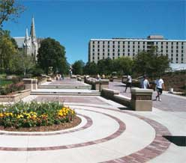
A view of Swanson Hall, the location of freshman honors community.

Honors Day
Wednesday, April 12, 2006

Sponsored in part by a grant from the Council on Undergraduate Research, Psychology Division (Washington, D.C.)

PRESENTATIONS are listed in alphabetical order by presenter’s last name.

Mary A. Adams
Oral Presentation: 3:15 p.m. – 3:30 p.m. Section 3
Faculty Sponsor: Dr. Michael Nichols, Department of Physics, Creighton University

Monitoring Production of Nitric Oxide in Osteoblast-like Cells by QPCR and a Greiss Reagent Assay

While it is well known that bone mass changes in response to biomechanical loading, the fundamental cellular mechanisms that regulate these changes remain unknown. Nitric oxide, produced by nitric oxide synthase (NOS) 3 in response to inflammatory stimuli, is thought to regulate bone remodeling. The pro-inflammatory cytokine interleukin 1β (IL-1β) is a known inducer of NOS3 expression in osteogenic cell lines. In this study, mouse osteoblast-like cells of the MC3T3-E1 cell line were treated with IL-1β under varying conditions. After treatment with IL-1β, gene expression was quantified by quantitative PCR (QPCR), and NO levels in the culture medium were quantified using Greiss reagent. The levels of NOS3 and nitric oxide in interleukin-treated cells as well as the implications for future studies will be discussed.

Tamika L. Butler
Oral Presentation: 4:45 p.m. – 5:00 p.m. Section 2
Faculty Sponsor: Dr. Stephen Jefferson

Psychological Impact of the film, The Angry Eye, on Participants.

The project will examine the psychological impact of the film, The Angry Eye, on participants. This film is often used in diversity training programs, but no research to date has examined its effectiveness in changing attitudes. We are proposing pre-test study using a Solomon Design. Tor the study we will recruit four groups with a goal of getting 150-200 participants. Two groups will be exposed to the independent variable (i.e., viewing The Angry Eye film) and two groups will not. Two groups (one control and one experimental) will be exposed to a pretest, while two matching groups will not. Finally, all groups will complete a posttest assessment examining their attitudes about social hierarchies and whit privilege.

We are currently examining what scales to use to measure racism, white privilege, social hierarchies, and white guilt. We hypothesize that of those who are pre-tested and watch the film, their level of racism will decrease. Also, their awareness of social hierarchies and white privilege will increase. Additionally, we believe that the participant’s levels of white guilt will also increase.

Of the groups not being pre-tested, we believe that the group who watches the video will have similar outcomes of the group who was pre-tested and watched the film.

Christopher W. Cook
Oral Presentation: 4:15 p.m. to 4:30 p.m. Section 4
Faculty Sponsor: Mrs. Theresa Carstens, Department of Health Administration and Policy, Creighton University

Quality in Health Care

The methods for addressing the health care’s “triad” of issues—cost, quality, and access—have long been the subject of clinical and legislative debate. Recent decades have seen many legislative attempts to achieve the correct balance of these issues, including the Health Maintenance Organization Act of 1973 and the Health Care Quality Improvement Act of 1986. Such policies have been effective, to varying degrees, in assuring cost containment and improving access to care. Quality, however, is more difficult to measure and profoundly more difficult to guarantee. Can health care quality be objectively defined? If so, can it be legislated?

Justyna A. Dobrowolska
Oral Presentation: 3:45 p.m. – 4:00 p.m. Section 4
Faculty Sponsor: Dr. Cynthia Gibson, Department of Psychology

Amyloid Precursor Protein, Phosphorylated Tau, and Microtubule-Associated Protein Expression in the Mouse Brain Following Repeated Mild Traumatic Brain Injuries

The emergence of amyloid β plaques and neurofibrillary tangles (NFTs), due to phosphorylated tau protein, occurs in both Alzheimer’s disease (AD) and traumatic brain injury (TBI). Therefore, TBI may increase the likelihood of later AD pathology. Amyloid β plaques are a result of cleavage of amyloid precursor protein (APP) by β- and γ-secretases and are now known to be central to the degeneration of neurons during AD. Tau is a microtubule-associated protein (MAP) associated with axons. Tau binds to microtubules (MTs) and the result is a stable MT complex. However, when tau is phosphorylated, there is a reduction in its ability to bind to MT, and stability of the MT diminishes, resulting in a NFT. Our objective was to test whether multiple mild injuries produce cumulative damage similar to a single, more severe injury. Therefore, we examined the expression of APP, MAPII, and phosphorylated tau staining 15 days post-injury in the cortex and hippocampus of mice subjected to 0, a, 4 or 6 mild TBIs incurred using only in the CA1 and dentate gyrus of the hippocampus at this time point. Further investigation of MAPII and phosphorylated tau expression will be performed.
Funding by NIH from the INBRE Program.

Rebecca A. Donahue
Poster Presentation: 3:30 p.m. – 4:30 p.m. Section 5
Faculty Sponsors: Dr. Martin Hulce, Department of Chemistry, Creighton University and Dr. Terrence Donohue , University of Nebraska Medical Center

The Effects of Proteasome Inhibitors and Ethanol on Protein Aggregation and Proteasome Activity

My study examined the effects of proteasome inhibitors and ethanol on proteasome activity, the formation of intracellular protein aggregates as a result of proteasome inhibition, and the proteolytic susceptibility of protein aggregates. I found that known proteasome inhibitors demonstrated much larger inhibitions of the proteasome than ethanol, and that cells treated with ethanol did produce protein aggregates that were resistant to degradation by the proteasome.

Kali E. Forbes
Oral Presentation: 3:15 p.m. – 3:30 p.m. Section 1
Faculty Sponsor: Dr. Heather Fryer, Department of History, Creighton University

Mardi Gras: Fertility in Two Different Celebrations

Due to media coverage, the American has very limited knowledge about Mardi Gras in New Orleans. Many believe that it is an extended drunken party for college students because of what is seen on television, and that type of celebration does exist. However, there is an entire aspect of local, family oriented Mardi Gras celebration that is rarely put forward for the public. Despite the disparities between the two celebrations, both have roots in ancient pagan celebrations of fertility.

Lindsey R. Goetz
Oral Presentations: 4:15 p.m. – 4:30 p.m. Section 3
Faculty Sponsor: Dr. Diane Cullen, Department of Biomedical Sciences, Creighton University

The Effect of Tobacco Smoke Exposure on Osteocyte Apoptosis in Tibia Bone of the Female Rat

Cigarette smoking is a major health risk implicated in numerous cancers as well as in a variety of cardiovascular and respiratory diseases. Smoke exposure also contributes to low bone mass and bone fragility and has been linked to an increased incidence of early

menopause and osteoporosis in women. In bone, the syncytial network of surface cells and embedded osteocytes is key to the regulation of bone metabolism. To elucidate mechanisms underlying the bone response to tobacco exposure, we hypothesized that the negative effects of cigarette smoke on bone integrity are associated with decreased osteocyte viability. To test this, we quantified percent apoptotic osteocytes in tibia bone from smoke exposed, ovariectomized, smoke exposed/ovariectomized, and sham female rats. Apoptotic osteocytes were identified by the TUNEL reaction and differences were tested using two-way ANOVA (P<0.05).

Carolyn M. Green
Oral Presentation: 3:45 p.m. – 4:00 p.m. Section 1
Faculty Sponsor: Dr. Julie Soukup, Department of Chemistry, Creighton University

The Guanine Riboswitches Control of Metabolic Functions Before and After Site Specific Mutagenesis

Mutant riboswitches have been constructed and studied in vitro to assay their ability to quickly and specifically bind ligand. Two interesting mutants, which demonstrated increased ability to link ligand have been inserted into the chromosome of B. subtilus to test their ability to regulate expression of a reporter gene. These mutants are intriguing because they are not found in nature as determined by the phylogeny described to date, and their effects can not be explained based on what is known about the tertiary structure of the riboswitch.

Colleen Hartsig *(Clare Boothe Luce Scholar Presenter)
Oral Presentation: 3:15 p.m. – 3:30 p.m. Section 4
Faculty Sponsor, Dr. Michael Cherney, Department of Physics, Creighton University

Development Plans for an Electromagnetic Calorimeter Control System for the ALICE Experiment

ALICE (A Large Icon Collider Experiment) is an experiment at the Large Hadron Collider (LHC) designed for the study of heavy-ion collisions. The aim of the experiment is to study the behavior of matter at high energy-densities. One of the component detectors is the Electromagnetic Calorimeter, designed to detect photon and electron signals. A control system has been designed to control and monitor the

functionality of this detector. A requirements document has been written that details the detector specifications as well as PVSS (Prozessvisualisierungs- und Steuerungssystem), the control software through which the detector will be monitored. Preliminary software developments will be presented as well as future plans.

Mary T. Johnson
Oral Presentation: 3:45 p.m. – 4:00 p.m. Section 2
Faculty Sponsor: Ms. Mary Helen Stefaniak, Department of English, Creighton University

Creative Writing Senior Project “Jonnah and Sarah”

This is a fictional narrative exploring the paths less traveled by two women of different backgrounds and intersecting lives.

Ann M. Kemper
Poster Presentation: 4:00 p.m. – 5:00 p.m. Section 5
Faculty Sponsor: Dr. Gintaras Duda, Department of Physics, Creighton University

Theoretical Calculations of Neutralino-Nucleon Cross Sections using Realistic Nuclear Form Factors from Elastic Scattering Data
Theoretical calculations of neutralino cross sections with various nuclei are of great interest to direct dark matter searches such as CDMS, EDELWEISS, ZEPLIN, and other experiments. However, these cross sections and direct detection rates are generally computed with standard, one to two parameter model-dependent nuclear form factors, which may not exactly mirror the actual form factor for the particular nucleus in question. As is well known, elastic electron scattering can allow for very precise determinations of nuclear form factors and hence nuclear charge densities for spin-zero, spherical nuclei. We use charge densities derived from elastic electron scattering data to calculate model independent form factors for various spin-zero nuclei important in dark matter searches such as Si, Ge, and S. DarkSUSY, a publicly-available advanced numerical package for neutralino dark matter calculations, is used to calculate neutralino-nucleon cross sections using both the standard form for the form factor and the model independent form factors extracted from elastic electron scattering data. We have found that for nuclear recoils in the range of 1-100 keV significant differences in cross sections and rates exist when the model independent form factors are used.

Jennifer M. Larson
Oral Presentation: 4:15 p.m. – 4:30 p.m. Section 2
Faculty Sponsor: Dr. Terry Clark, Department of Political Science, Creighton University

Necessary Conditions for Democracy: An Evaluation of Crisp Set and Fuzzy Set Methods

Variables relating to the development of democracy, as well as most topics in comparative politics, are qualitative. Hence, imprecision is inherent not merely in the data collection process, but in the actual data themselves. The purpose of this paper is to examine the methodology commonly employed to study questions of causation and necessity using data that are not inherently quantitative. As an alternative to standard statistical methods, fuzzy set theory, a relatively new branch of mathematics, offer methods for working with imprecise, qualitative data, which may offer more reliable and predictive results for questions in the social sciences.

Jackie K. Lee
Oral Presentation: 4:45 p.m. – 5:00 p.m. Section 1
Faculty Sponsor: Dr. Eileen Burke-Sullivan, Department of Theology, Creighton University

Benedictine Monasticism as an Environmental Spirituality

One criticism of Christianity in modern times is that it is unable to answer the environmental crisis that faces the world. In light of this criticism, In light of this criticism, many Christians have come up with new methods of spirituality that take the environment into account. Monastic communities have taken the lead in this new-found spiritual movement, Benedictines in particular. Much of the Rule of Saint Benedict, the book written by Saint Benedict and the basis for the Benedictine movement, has been reinterpreted to answer ecological issues.

Jariel A. Rendell
Poster Presentation: 3:15 p.m. – 4:15 p.m. Section 5
Faculty Advisor: Dr. Isabelle Cherney, Department of Psychology, Creighton University

The Lines Are Draw: Sex Differences on Paper and Tablet Computer Tests of Visuospatial Abilities.

Previous research has identified robust sex differences on certain paper-and-pencil tests of visuospatial ability. In order to determine whether the testing medium affects this cognitive sex difference, male and female participants’ performance was examined on visuospatial tasks involving varying fine motor and perceptual demands presented in traditional and tablet computer form. Results indicated that both male and female participants performed better when tested on paper than when tested on the tablet computer, but males tended to outperform females in both conditions. Nevertheless, a large fine motor component reduced or eliminated some cognitive sex differences.
Sponsored in part by a Nebraska EPSCoR grant

Mark T. Rusch
Oral Presentation: 3:15 p.m. – 3:30 p.m. Section 4
Faculty Sponsor: Dr. Lorie Vanchena, Department of Modern Languages and Literatures, Creighton University

Visions Through the Windshield: Voyeurism, Bildungroman, and the Highway in Wenders’ “Road” Trilogy

An investigation into observation, personal development, and how the road encompasses these two concepts in the films of German director Wim Winders’ mid-1970’s “road” trilogy: Alice in den Städten, Falsche Bewegung, and Im Lauf der Zeit.

Adam J. Schumacher
Oral Presentation: 4:15 p.m. – 4:30 p.m. Section 1
Faculty Sponsor: Dr. Dave Reed

Developing a Web Based File Management System

The goal of this project is to develop an Internet based file storage system that will allow users to store and access their files from anywhere in the world. The system will be reliable, secure and easy to use. It will utilize technologies such as Apaehe and PHP as well as networking protocols http, ftp, and SSL.

Kashmir K. Singh
Poster Presentation: 3:15 p.m. – 4:15 p.m. Section 5
Faculty Advisor(s): Dr. Fathi Halaweish, Dr. Yadhu N. Singh, South Dakota State University

Hepatotoxicity Potential of Saw Palmetto (Serenoa repens) in Rats

Saw Palmetto (Serenoa Repens) is a herbal drug used to treat symptoms of benign prostatic hyperplasia (BPH) and lower urinary tract symptoms (LUTS). There has been a report that a preparation containing this herb has caused cholestatic hepatitis in one person and some indications exist that it may have the potential to produce liver toxicity. The purpose of this research was to evaluate the effect of saw palmetto on liver function in rats by measuring its effects on several enzymes and formation of malondialdehyde (MSA), a byproduct of lipid peroxidation. A significant increase in these parameters is considered an indication of liver toxicity. The results showed that there was no significant difference in the animal body weight, enzyme activity, or MDA formation at either time or dosage level, compared to the controls. The data indicate that in the dosages and time periods tested, saw palmetto did not produce any significant effect on the normal biological markers of liver toxicity.

Kelsey Tinkum
Oral Presentation: 4:45 p.m. – 5:00 p.m. Section 3
Faculty Sponsor: Dr. Laura A. Hansen, Biomedical Sciences Department, Creighton University

Keratinocyte Migration and Adhesion are Regulated by erbB2

Skin cancer is an important human health concern, with one million cases of non-melanoma skin cancer in the United States each year. We have demonstrated that erbB2 increases skin carcinogenesis in mice. Microarray analysis revealed that genes important in cell migration and adhesion, processes important in cancer progression, are regulated by erbB2. From this data, we hypothesized erbB2 is required for normal adhesion and migration of skin cells. As predicted, both adhesion and migration were decreased upon inhibition or genetic ablation of erbB2 in cultured skin cells. Investigations are underway to understand the mechanisms through which erbB2 regulates these processes.

Brittany G. Travers
Poster Presentation: 3:30 p.m. – 4:30 p.m. Section 5
Faculty Sponsor: Dr. Isabelle Cherney, Department of Psychology

Adult Perceptions of Children’s Competence

Understanding how adults perceive children as competent to exercise certain rights is important to the issue of children’s rights. Six versions of a survey were administered to 48 men and 84 women. Each version assigned a different age and sex to the children in the 30 vignettes. The results indicated that participants generally labeled the children as being at Kohlberg’s preconventional level of morality regardless of age. Participants were also more likely to grant the rights to children in the oldest (16-17) age bracket.
Funded in part by the Creighton University College of Arts & Sciences

Erin Wallace
On-line Presentation Available Fall 2006
Faculty Sponsor: Dr. Dennis Flood

Co-Teaching in Today’s Classrooms

Co-teaching is a method of providing inclusive classrooms in schools. First, I will examine the history and current application of this process. Second, after reviewing their available data, I will provide an extensive resources section. These resources will become available to both pre-service teachers and professors at Creighton University, and will be useful for administrators and/or teachers who wish to know more about specific aspects of co-teaching. Third, my project will include an interview with an administrator with experience in implementation. Last, I hope to include input from student and/or teachers who are currently part of the co-teaching experience.

Laura M. Zapapas
Oral Presentation: 3:45 p.m. – 4:00 p.m. Section 3
Faculty Sponsor: Dr. Charles Austerberry, Department of Biology, Creighton University

The Science and Ethics of Embryonic Stem Cell Research: An Analysis of New Approaches

Stem cell research is changing the face of modern medicine, yet remains held back by ethical concerns of creating and destroying human embryos. Many new techniques of generating embryonic stem cells attempt to avoid these hurdles. This presentation will examine the science behind some of these techniques, experimental results of those procedures, and whether or not they are practically and ethically feasible for future research.

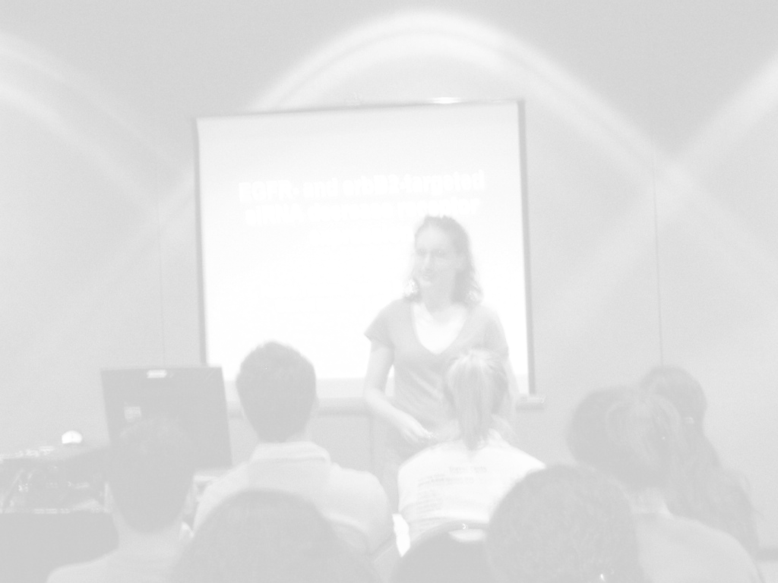

“Education in our times must try to
find whatever there is in students
that might yearn for completion,
and to reconstruct the learning that
would enable them autonomously
to seek that completion”.
Alan Bloom
American Author

