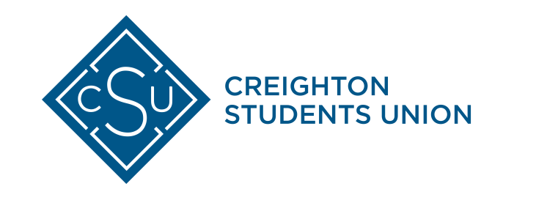

Date: November 12th, 2018
Referendum: #18-03B – Plastic Straw Phase-Out

Sponsors: Patrick Marta, Creighton Students Union President 2018
Gabrielle Baker, College of Arts and Sciences Representative

Purpose: To phase out the distribution of non-essential single-use plastic straws on the Creighton University campus in favor of necessary alternatives starting in Fall of 2019.

Whereas: As a Jesuit, Catholic institution, we understand the interconnectedness of our mission and the global impact of sustainability as an environmental, social, and economic issue.

Whereas: Creighton University has made “a renewed commitment to promoting ecological justice at Creighton and within society at large”. (Creighton University Strategic Plan, November 2017)

Whereas: Creighton Students Union “is dedicated to the enhancement of the educational, social, and cultural environment on campus” in part by “encourage[ing] members of the Creighton community to contribute positively to the university and greater communities.” (Creighton Students Union Constitution, 2017).

Whereas: Global environmental well-being has been recognized as an issue of social justice by the Catholic Church: “We have to realize that a true ecological approach always becomes a social approach; it must integrate questions of justice in debates on the environment, so as to hear both the cry of the earth and the cry of the poor.” (Laudato Si, 2015)

Whereas: To fully live according to our CSU and university mission, it is crucial that we provide opportunities for Creighton to cultivate environmentally conscious individuals and to encourage broader involvement in campus sustainability efforts.

Whereas: The higher mission to eliminate single-use plastics has garnered broad support across campus, specifically leaders from the Office of Sustainability Programs and the Inter-Residence Hall Government.

Whereas: Starbucks, a campus partner, is committed to phasing out the distribution of plastic straws by 2020.

Whereas: Phasing out single-use plastic bags and straws on campus starting in Fall 2019 is deemed an attainable goal by the Director of Housing and Auxiliary Services.

Whereas: Campus dining and facilities have already demonstrated a commitment to reduce food and plastic waste through food conservation efforts, installation of water bottle fillers, and providing reusable dining options.

Whereas: Paper straws will be available upon request at campus vendors to satisfy the preference or need for straw use.

Whereas: A small number of plastic straws will still be available to serve individuals with accessibility needs.

THEREFORE, BE IT ENACTED THAT…

The Creighton Students Union Sustainability Fund formally proposes the phase-out of non-essential single-use plastic straws on the Creighton University campus starting in Fall 2019.
Proposed Vote Date: Wednesday, December 5th, 2018

Ballot Summary:

Ref #18-03B: Plastic Straw Phase-Out - The Plastic Straw Phase-Out would phase out distribution of non-essential single-use plastic straws at food vending locations across campus. Paper straw alternatives will be available by request. A small amount of plastic straws would be kept for essential use.
If passed, preliminary steps towards this phase-out will be taken in Spring 2019, with phasing-out beginning in Fall 2019.

Vote YES to initiate the phase-out of plastic straws
Vote NO to retain current straw distribution

Respectfully Signed,
Patrick Marta, Creighton Students Union President 2018
Gabrielle Baker, College of Arts and Sciences Representative

