Agenda
Tuesday, November 18, 2019

Present: Donna, Jessie, Colin, Kailen, Maggie, Colby, Tyler, Andrew, Braden, Molly, Kieran, Neetu, Kylie, Kristyn, Michele

Not Present: Caitlin

- Call to Order: 6:48

- Reflection
  - Andrew Valiquette, Creighton Medical School Government President

- Roll Call/Attendance

- Approval of Minutes
  - 11.05.2019
    - Motion: Kylie
    - Second: Andrew
      - This motion passes 6-0-2

- Old Business

- New Business

  - Resolution #19-04
    - *Presenters proceed to present*
    - Motion to forego reading
      - Motion: Tyler
      - Second: Kylie
    - Motion to vote
      - Motion: Braden
      - Second: Kylie
        - This motion passes 8-0-0
  - Resolution #19-06
    - *Presenters proceed to present*
    - Motion to forego reading
      - Motion: Andrew
      - Second: Tyler
    - Motion to discuss
      - Motion: Braden
      - Braden: Is this just for health sciences library?
        - Bradley: For both Reinert and Health Sciences
      - Point of Information: Michele
        - Is this the most recent version that was passed at BOR last night?
        - Donna: Yes, there was a friendly amendment made on Sunday and I sent this to Mitchell to pull up for the Board.
          - Michele: Does the Cabinet have the version that was approved at Board?
        - *Donna proceeds to pull up most accurate version*
    - Motion to Vote:
      - Motion: Braden
      - Second: Neetu
        - This motion passes 7-0-1
  - Resolution #19-05
    - *Presenters proceed to present*
    - Motion to forego reading
      - Motion: Kylie
      - Second: Andrew
    - Motion to vote
      - Motion: Kylie
      - Second: Kristyn
        - This motion passes 8-0-0
  - Resolution #19-03
    - *Presenters proceed to present*
    - Motion to forego reading
      - Motion: Neetu
      - Second: Tyler
        - Braden: This is a little different from dining as we have visitors that come from all over.
          - Donna: There will be reusable bags for purchase for $1. There will also be paper alternatives available as well
    - Motion to vote
      - Motion: Braden
      - Second: Kylie
        - This motion passes 8-0-0
  - Bylaw Change
    - *Presenters proceed to present*
    - Motion to forego reading
      - Motion: Andrew
      - Second: Braden
      - Braden: How does the marketing pay change affect the budget?
        - Colin: This will decrease the budget.
        - Andrew: How much do they currently get paid?
          - Donna: They can work 10 hrs for $12.50 per hour. With this change, we will rank projects based on difficulty as they will be paid on a “per project” basis.
    - Motion to vote:
      - Motion: Braden
      - Second: Kylie
        - This motion passes: 8-0-0
  - October Budget
    - *Colin proceeds to present budget*
      - Braden: Why do we pay for telephone service?
        - Donna: We are an independent service.
        - Michele: We are all on our own phone lines. So we must pay for those services
    - Motion to vote with stipulation on line item 7806:
      - Motion: Neetu
      - Second: Braden
        - This motion passes 8-0-0
  - Braden
      - Issues regarding the Gender Sexuality Alliance
        - GSA was putting together a tabling event regarding LGBTQ+ activists. This was passed along to several other entities but it got turned down as it needed to be more “mission centric”
        - Vice Provost said these lifestyles should not be celebrated and goes against the mission of the Catholic church
        - University does not protect/ support LGBTQ+ community
      - Came to Braden asking him what they can do
        - Just want to let Cabinet know what is going on
        - If you have any ideas about what can be done, please let Braden know
  - Creighton Students Union Expansion – Phoenix
    - Donna:
      - Med school runs on a system where they have a president that reports to the Creighton medical school president
      - Not getting another CSU President, but a Phoenix president that serves as a point of contact
      - Another conversation that needs to be had is funding. They are not charged a student fee in Phoenix
      - Everything would run the same expect you would have a Phoenix representative that you can keep in contact with
    - Kylie:
      - Including Phoenix would be fairly easy for our current structure
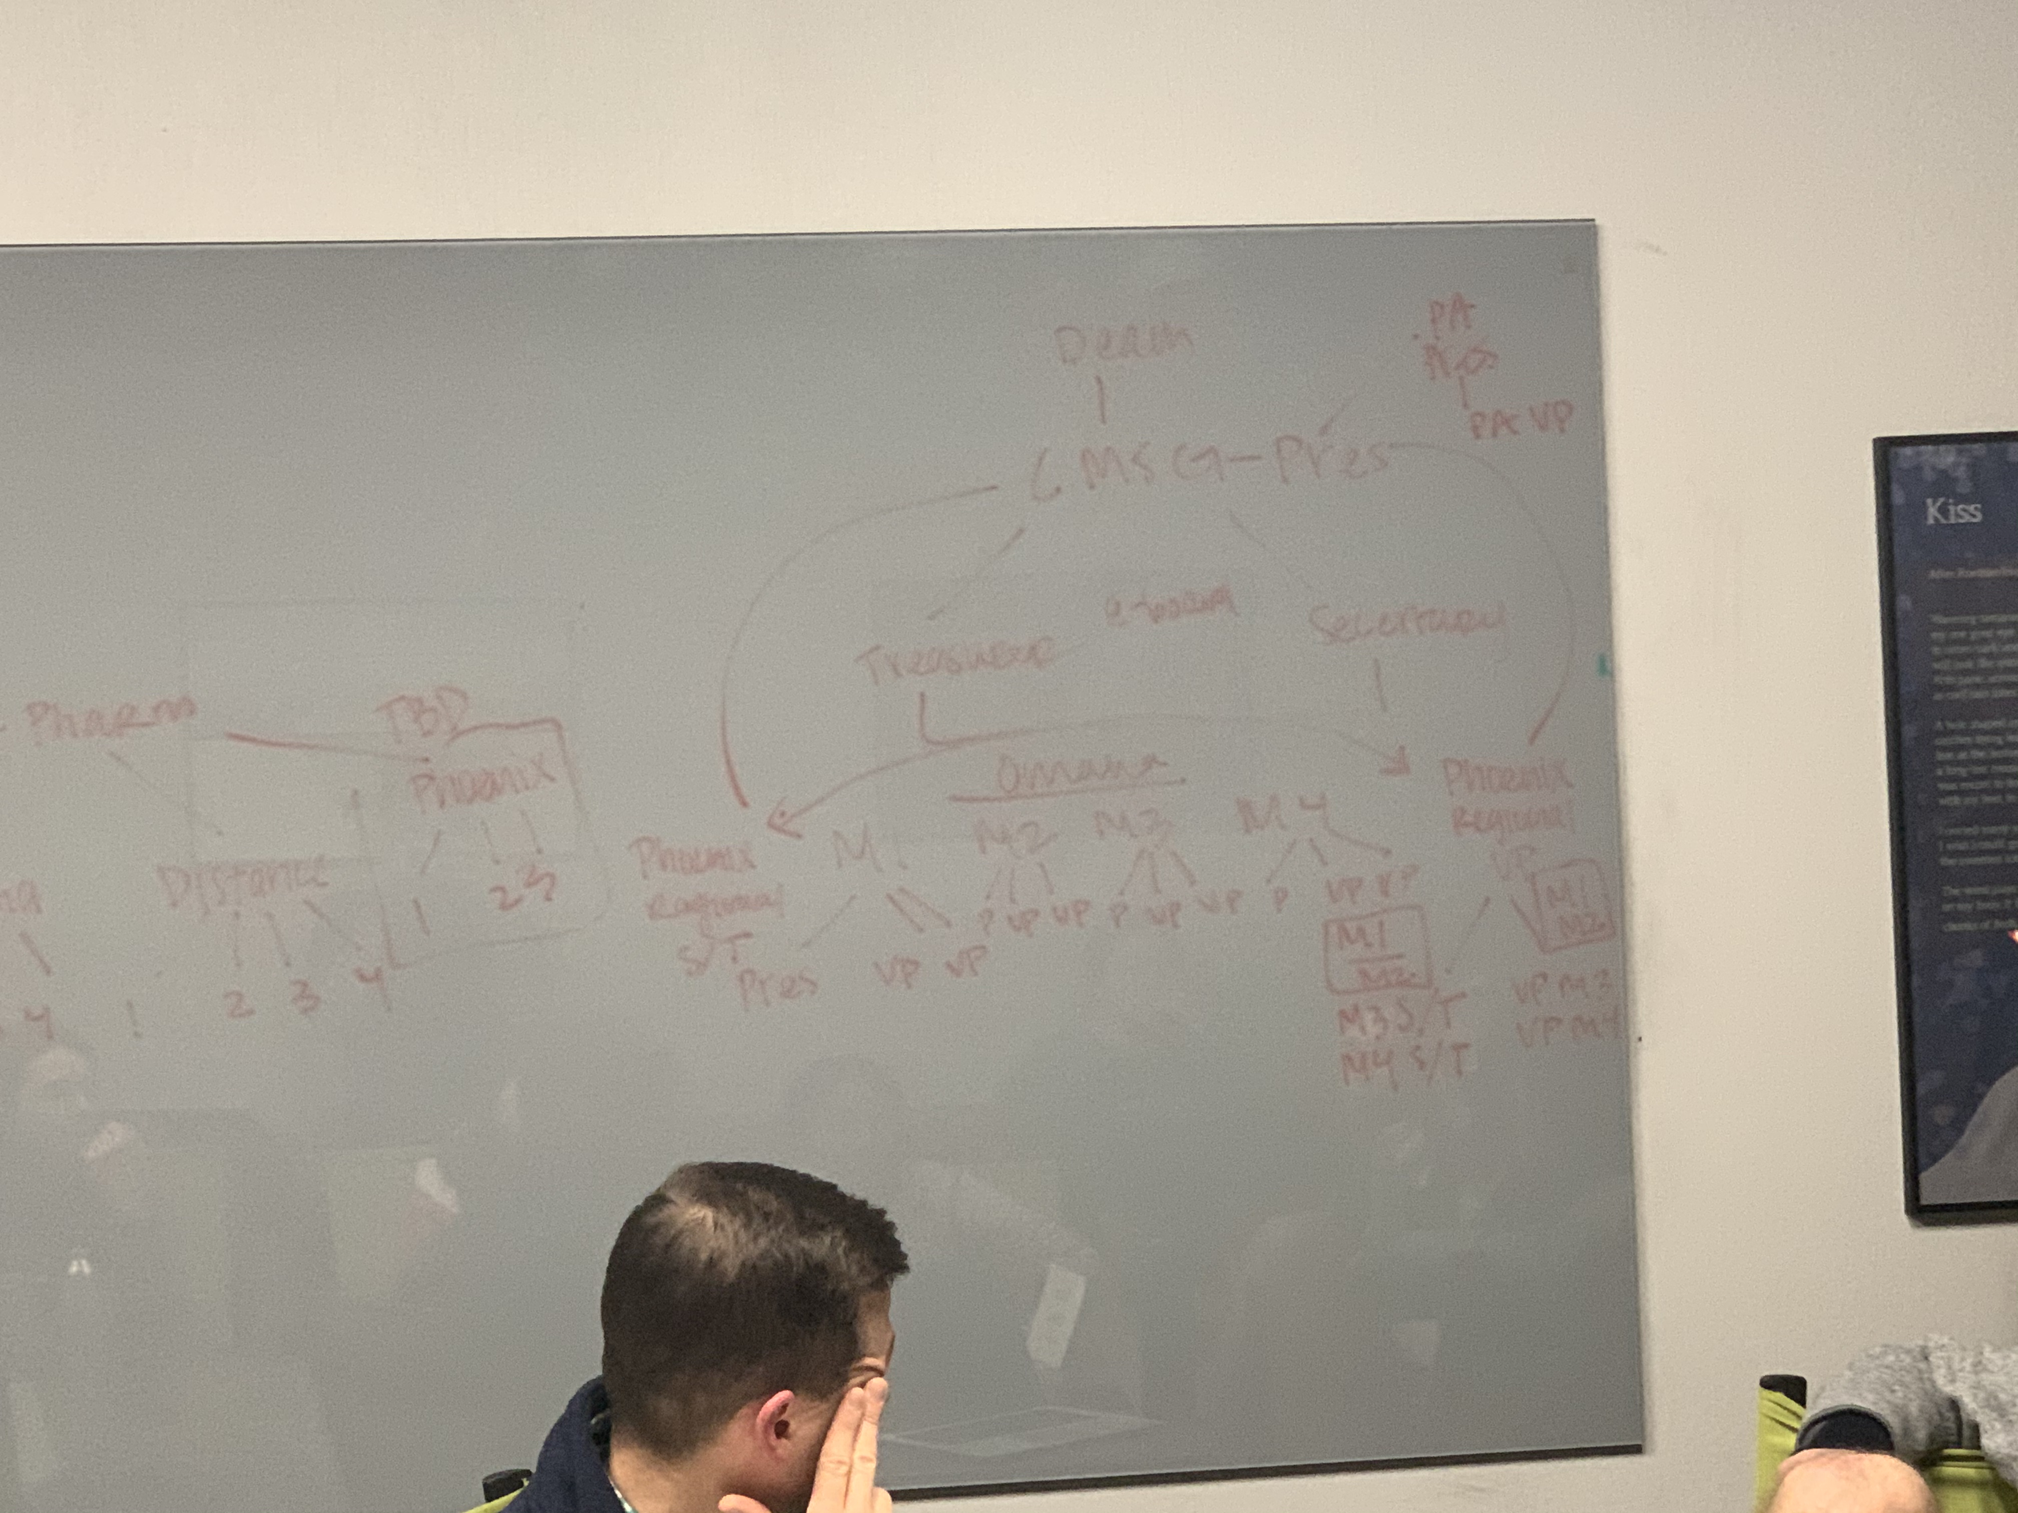
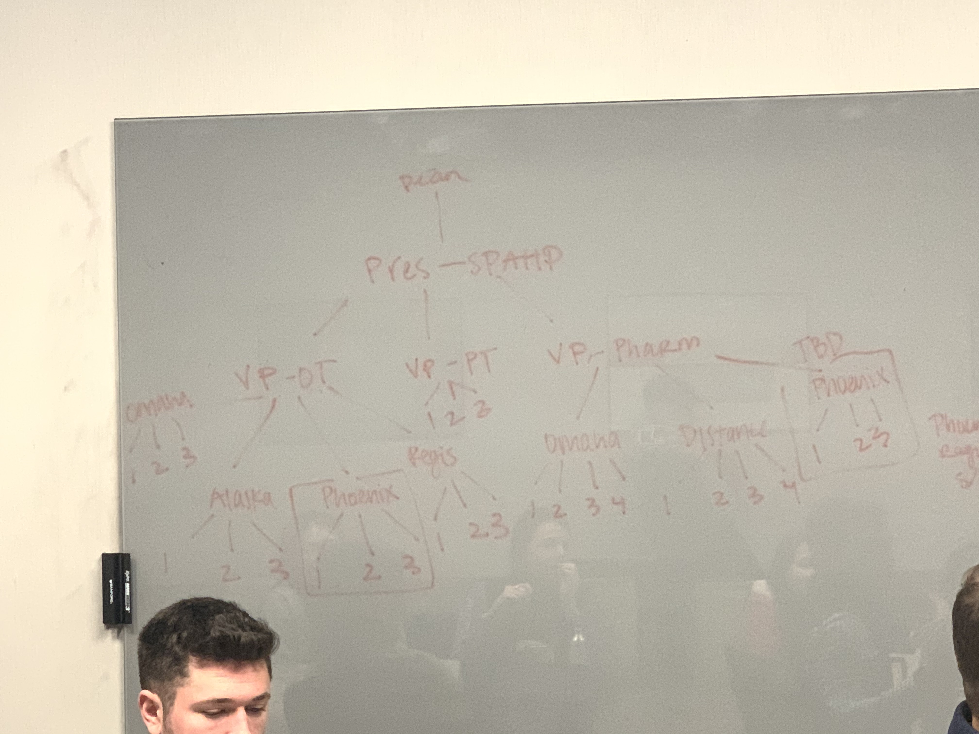
      - Phoenix will fall under the VP of OT and possibly under the VP of Pharm
    - Andrew:
    - Molly:
      - The main problem that they have is budget and funding
    - Donna:
      - So, the main question at hand is how to deal with funding in Phoenix
    - Michele:
      - Each school is coded differently based on their status, etc.
      - Nursing student in Phoenix are paying fees but most likely not coming back to CSU
    - Donna:
      - Michele: CSU cannot set the student fee or the percentage. The deans are working with the budget committee. You can give recommendations or advice, but CSU has minimal inputs
        - MOU: a portion of the student fee can be allocated back to Phoenix
      - We can make a recommendation to the University to look into charging Phoenix student a similar to student fee to those at Creighton in Omaha. From there we can start looking into a rebate for Phoenix.
- Adjournment: 7:50 p.m.

