Gloving Procedure for Double Gloves and Sleeves
- Don hair bonnet, gown, inner gloves, sleeves.
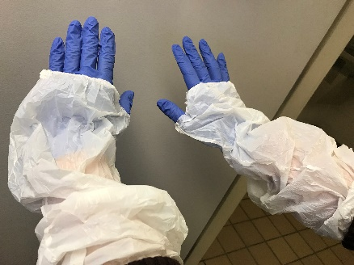

- Don 2nd pair of gloves over the inner glove/sleeves.
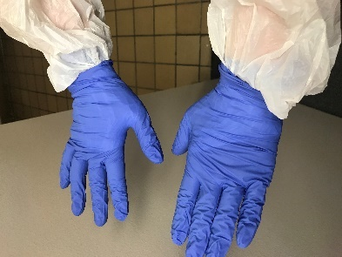

Degloving Procedure- Single Pair of Gloves with Sleeves
- With both hands gloved and sleeved, grasp the outside of one sleeve and pull sleeve off toward gloved hand.
- Continue pulling sleeve until it folds over and is held inside gloved hand.
- Grab outside of glove cuff and pull glove off wrist toward fingertips until glove folds over (dirty side in). Do not touch exposed skin with other gloved hand.
- Continue pulling glove toward fingertips until it is pulled off finger tips and glove is inside out.
- Hold dirty glove in the palm of your gloved hand.
- With ungloved hand, place two fingers under the sleeve of gloved hand.
- Slide fingers down toward gloved fingertips until sleeve folds over and is held in gloved hand.
- Slide fingers under cuff of remaining glove and continue to pull glove off from inside of glove surface.
- All contaminants should now be contained within the inside out glove.
- Discard gloves in appropriate waste receptacle. If hazardous place into biosafety trash receptacle.
1.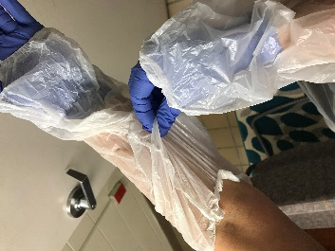 2. 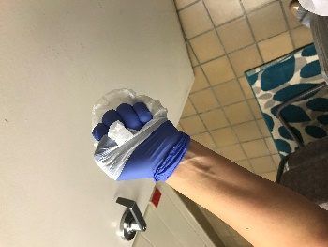 3. 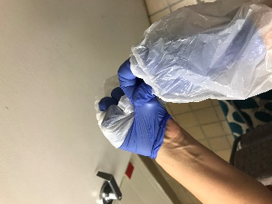 4. 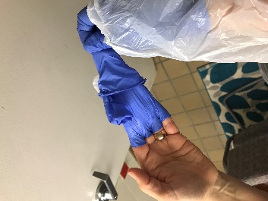
5. 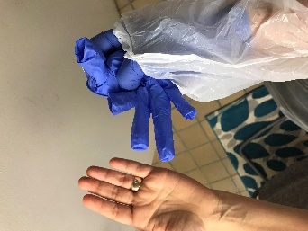 6. 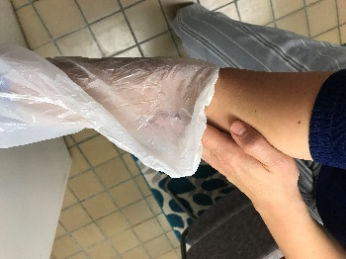 7. 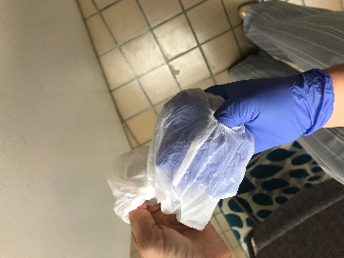 8. 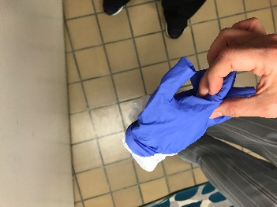

Removing only OUTER pair of gloves
- With both hands gloved, grasp near the cuff of one outer glove and pull glove off wrist toward fingertips until glove folds over (dirty side in). Do not touch inner glove or sleeve with other gloved hand.
- Continue pulling glove toward fingertips until it is pulled off finger tips and glove is inside out.
- Hold dirty glove in the palm of your remaining double gloved hand.
- With single gloved hand, place two fingers under cuff of double gloved hand. Slide fingers down toward gloved fingertips until glove folds over. This should also encase the other dirty glove.
- Grasp the fold of the glove and finish removing from hand.
- All contaminants should now be contained within the inside out glove.
- Discard gloves in appropriate waste receptacle. If hazardous place into biosafety trash receptacle.
- Your inner gloves and sleeves remain in place.
- 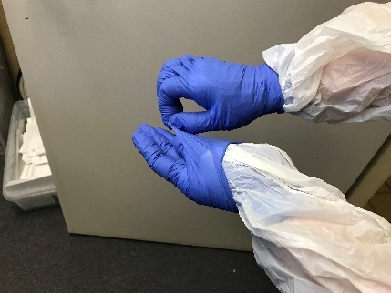 2. 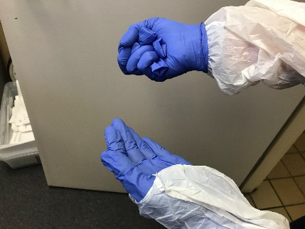 3. 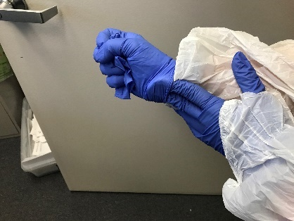
4. 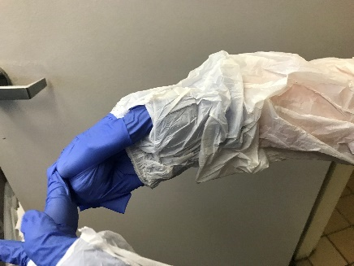 5. 