2022-2023 CFE Faculty Development Grant | 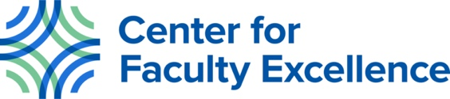

Mindfulness Training for Psychiatry Residents
- Cassie Eno, PhD, Medical Education Department, School of Medicine, Principal Investigator
- Kiely Madhaven, PhD, Medical Humanities Department, School of Medicine, Co-Investigator
- Jim Smith, PhD, Medical Humanities Department, School of Medicine, Co-Investigator
- Mary Sinclair, Medical Humanities Department, School of Medicine, Co-Investigator
- Rachel Jones, Student Affairs Department, School of Medicine, Co-Investigator

Abstract:
Clinical decision making (CDM) is a vital aspect of medical education and physician care. However, CDM lacks a clear conceptual definition, and there is no universally accepted framework for the teaching, development, and assessment of CDM skills and competencies. Creighton University School of Medicine (CUSOM) faculty introduced case- and team-based learning (CBL/TBL) to facilitate students’ development of CDM skills prior to their immersion into the clinical setting. Despite the well-established advantages of CBL/TBL, concerns have been raised by CUSOM faculty and students about the efficacy of this activity for student learning. This raises questions about the efficacy of CDM skills introduction in the pre-clinical years. The aim of this project is to (1.) gain a better understanding of CUSOM student and faculty perceptions of CDM, including the timing and methods of teaching this critical skill, and (2.) create faculty development experiences to improve how CDM is incorporated in the curriculum. A survey and focus group sessions will be designed to assess student and faculty perceptions of the delivery of CDM skills and expected proficiency throughout the medical curriculum. Using this data, faculty development experiences will be designed to improve the teaching of CDM in the pre-clerkship curriculum.

