Billy Bluejay
Omaha, NE 68124
555.555.555 • billybluejay@creigton.edu

February 21, 2017

CHI Health Bergen Mercy
7500 Mercy Rd
Omaha, NE 68124

Dear Hiring Manager:

Please accept my enclosed resume for the Patient Attendant position at CHI Health Creighton University Medical Center - Bergen Mercy. I am a junior at Creighton University pursuing a Bachelor of Science in Health Administration and Policy. I am deeply impressed by CHI’s leadership in providing quality healthcare for the Omaha community. This aligns with my aspiration to work for an organization dedicated to delivering patient-centered care and improving healthcare experiences for individuals.

Through my academic and volunteer experiences, I have developed strong communication, organizational, and interpersonal skills that I believe will make me a great fit for the Patient Attendant role. My coursework in Health Administration has provided me with a solid understanding of healthcare systems and patient care. Additionally, my volunteer work at Siena Francis House, a local shelter for individuals experiencing homelessness, has given me hands-on experience working with vulnerable populations. In this role, I’ve had the opportunity to assist with meal service, coordinate resources, and provide emotional support to those in need. This experience has deepened my commitment to providing holistic care, particularly to individuals facing difficult circumstances, and has strengthened my ability to connect with and support others in a healthcare environment.

Additionally, I have had the opportunity to shadow doctors in various clinical settings, which has given me a deeper understanding of patient care and the importance of creating a compassionate and supportive environment. This experience allowed me to observe healthcare professionals as they interact with patients, address their concerns, and deliver care in a way that prioritizes the well-being of each individual. These observations have reinforced my commitment to providing the highest standard of care and ensuring patients feel valued and heard.

I am eager to bring my dedication to compassionate patient care to CHI Health. As a Patient Attendant, I would be honored to contribute to the organization’s mission of delivering exceptional healthcare services. Thank you for your time and consideration. I can be reached by email at billybluejay@creighton.edu or phone at 555-555-5555. I look forward to the opportunity to discuss how I can contribute to your team.

Sincerely,

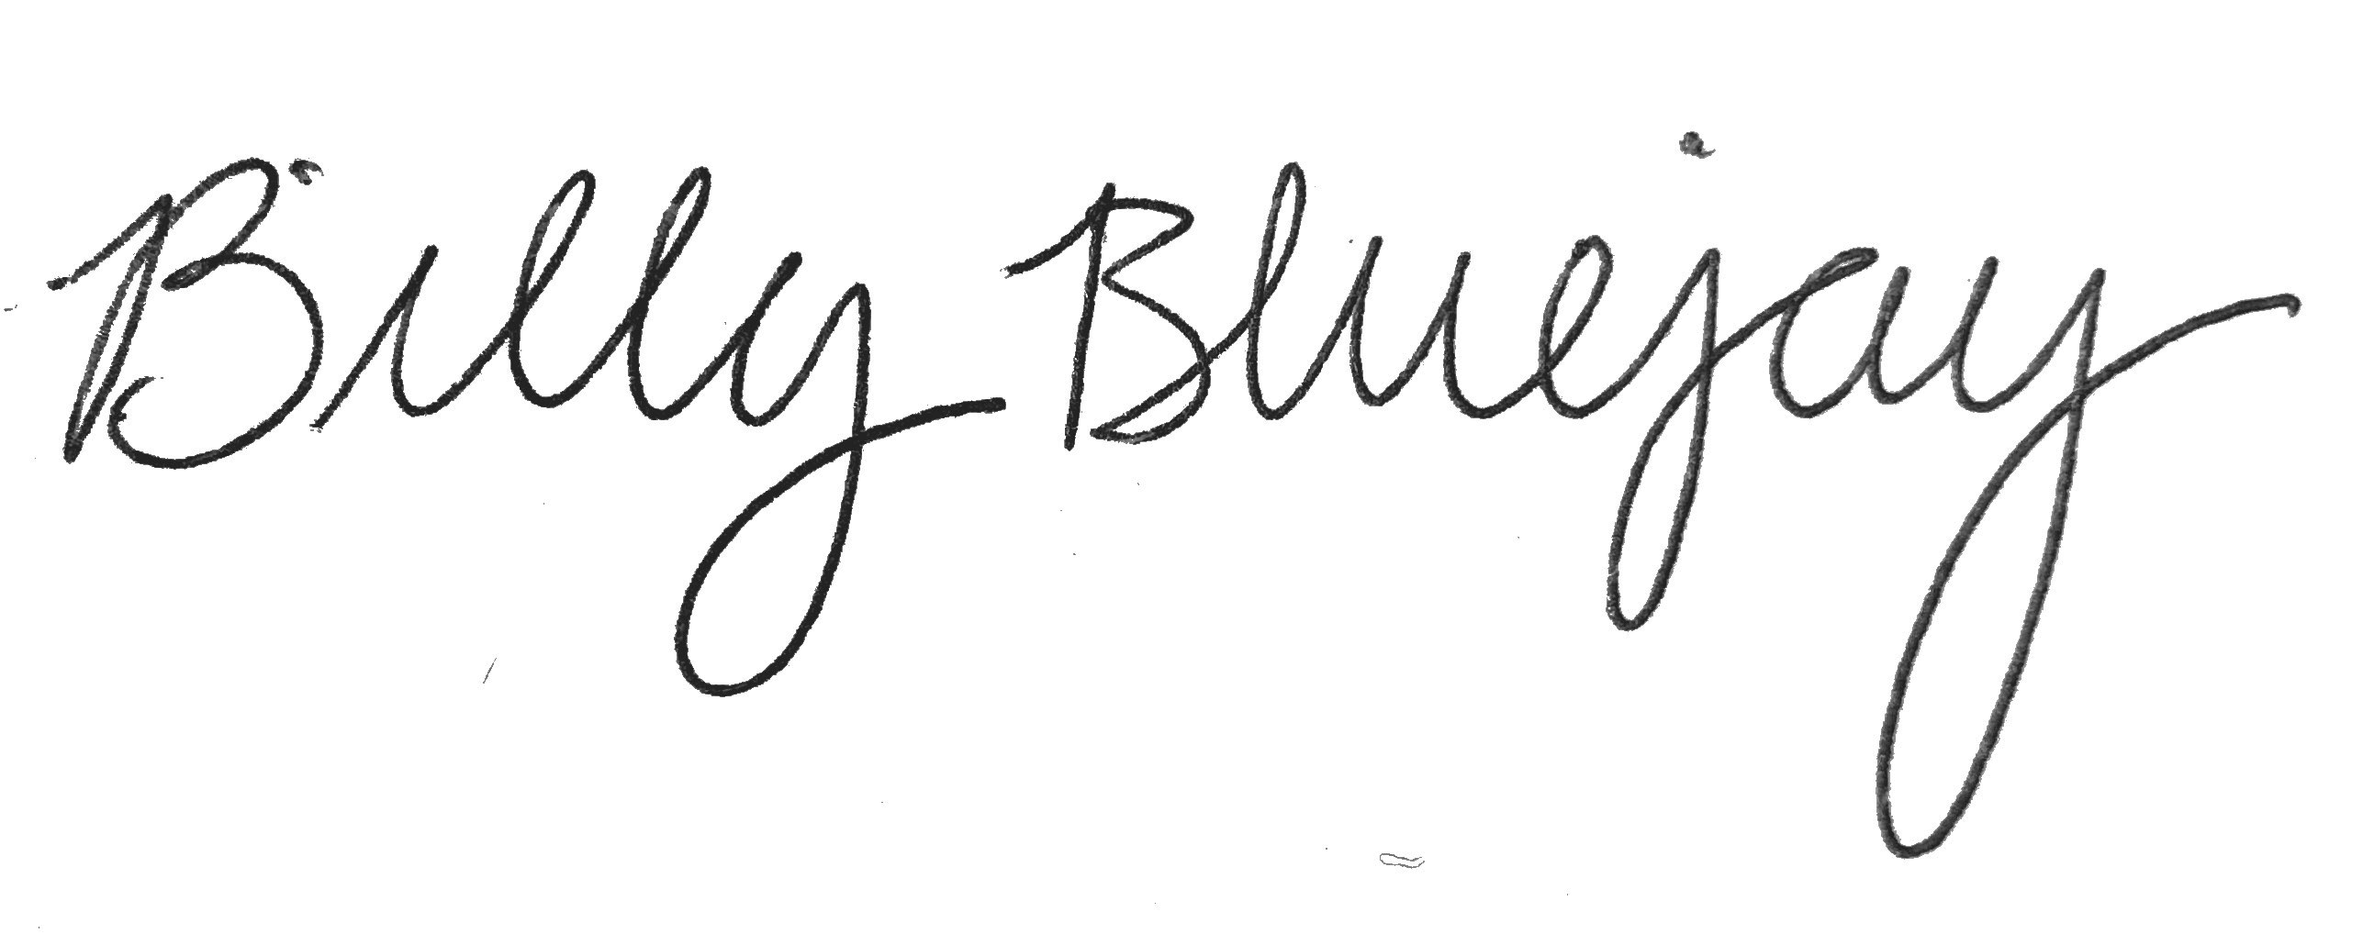

Billy Bluejay

